Ciedelle Honey Lou Dimalig – Gapasin College of Nursing
ACCOMPLISHMENT REPORT

September 9, 2020

- Create a group chat for the students of PhEd 133, NuCM 104 and NuCM 113

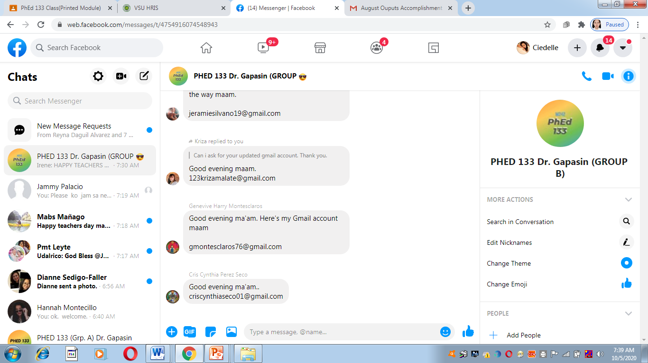

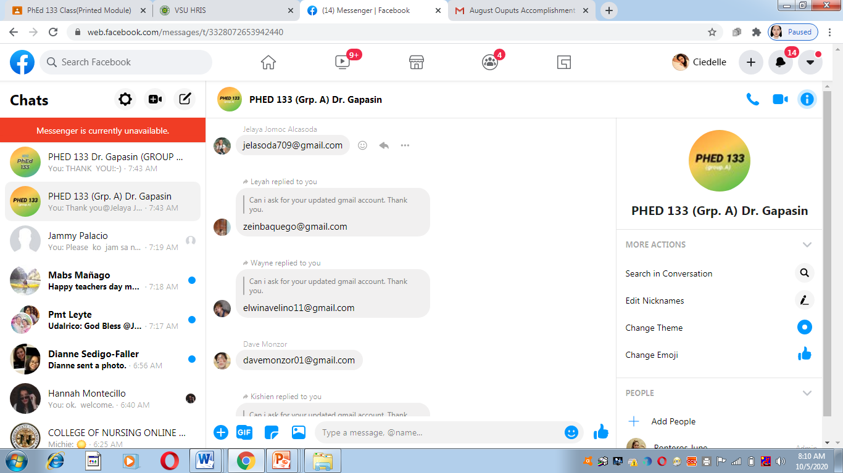

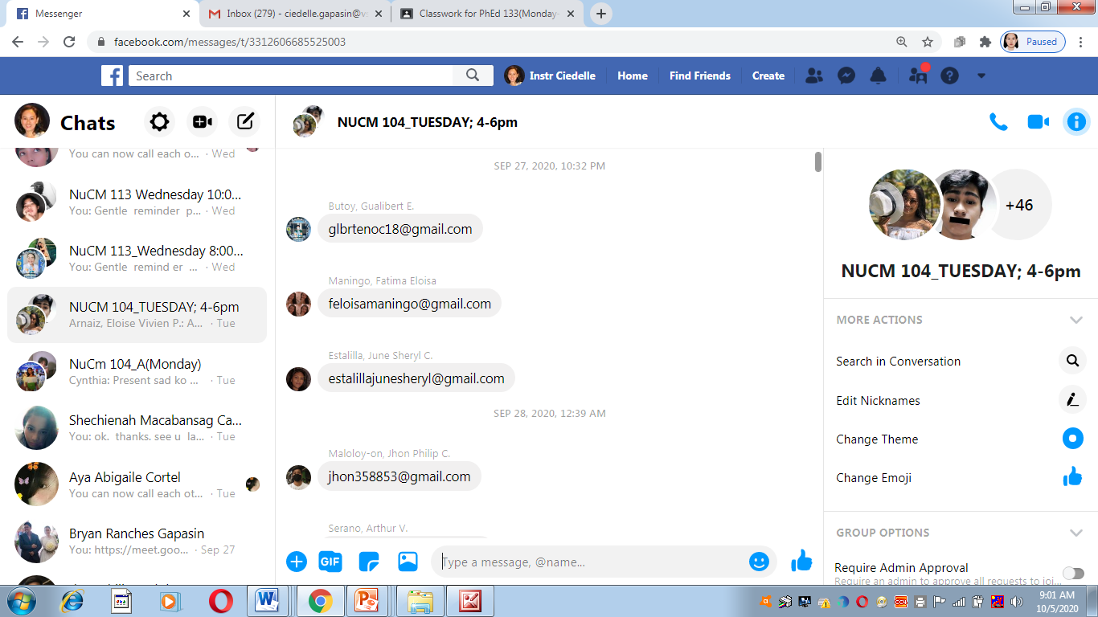
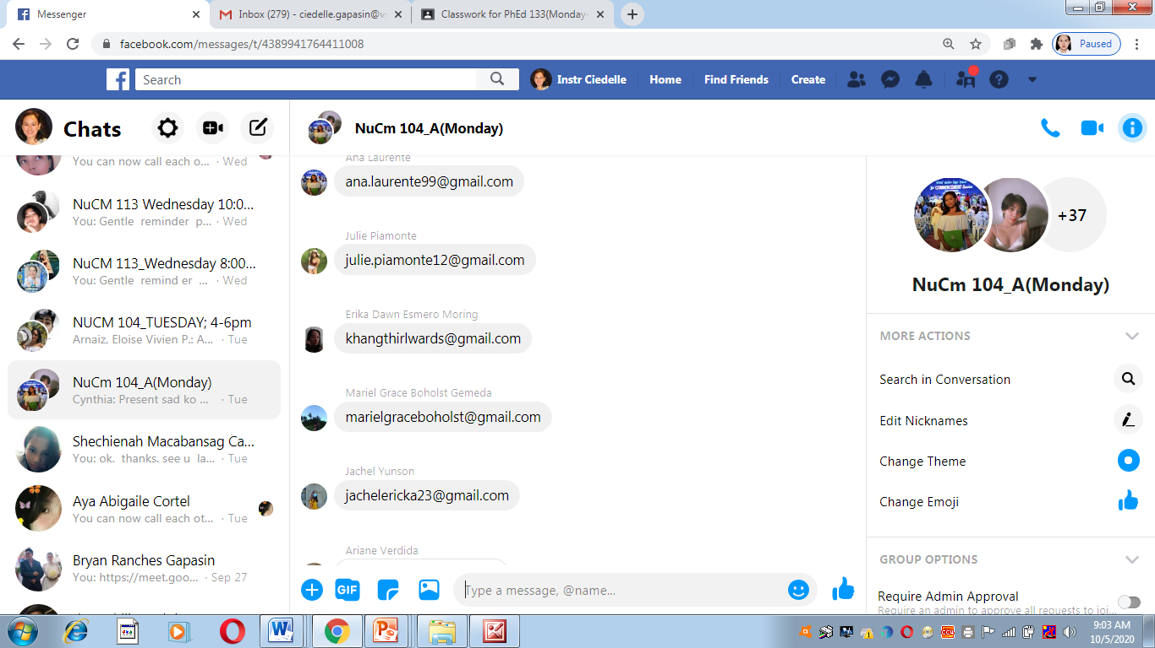

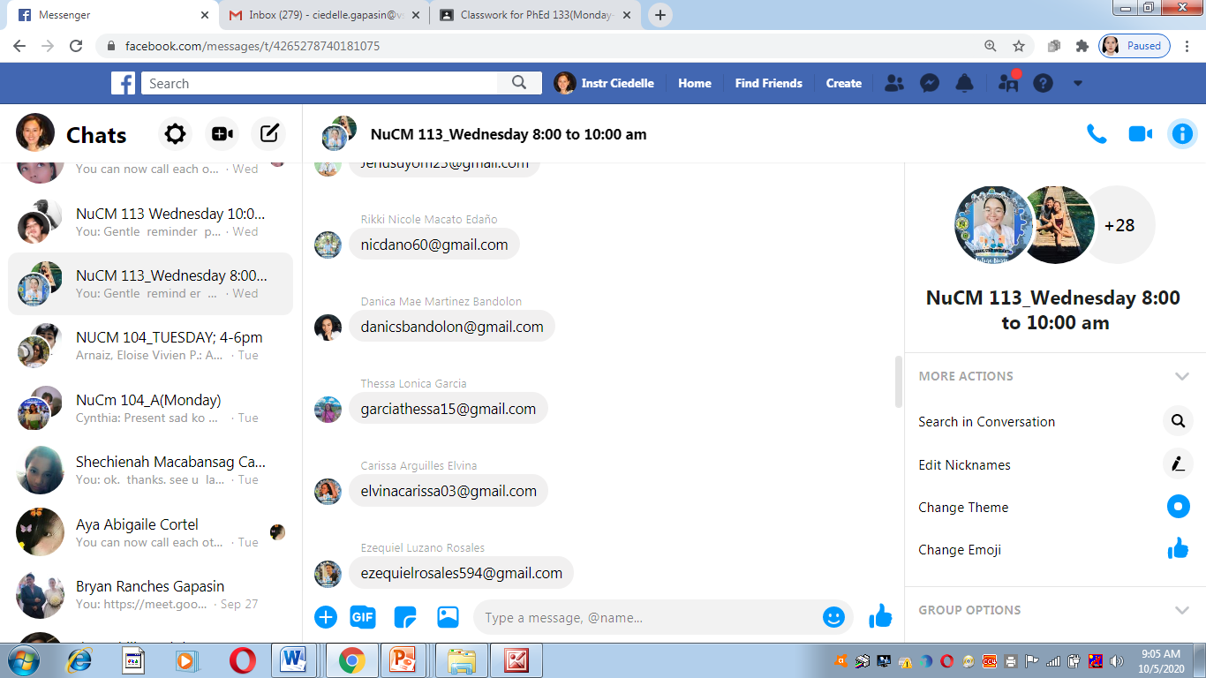
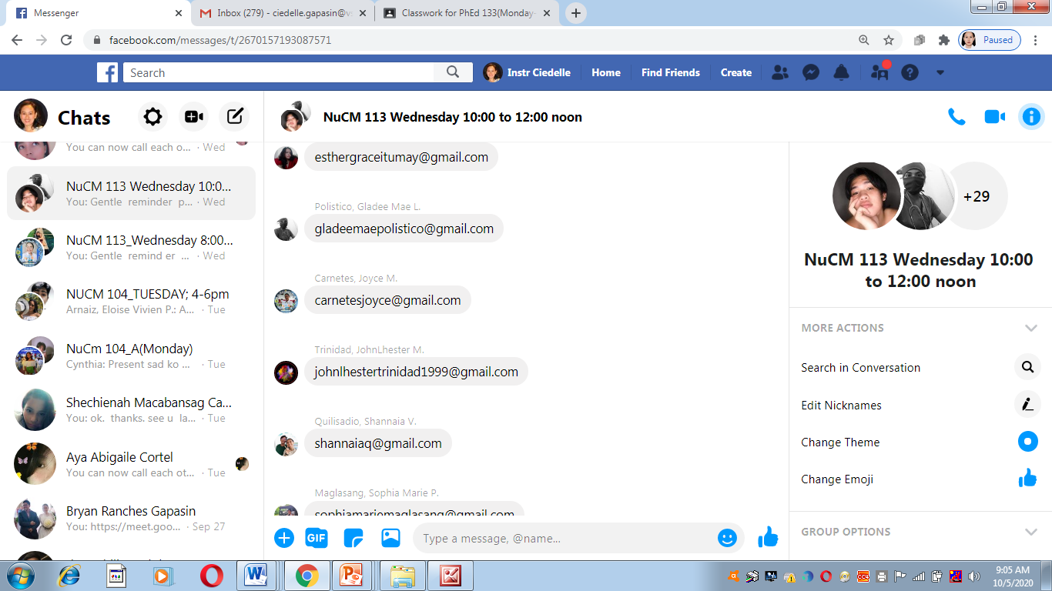

- Recorded Orientation( Audio).

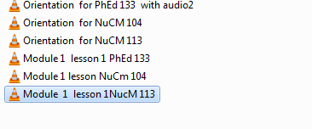

September 14, 2020
- Recorded lecture- discussion( audio) of the concepts. Convert powerpoint to windows media video.
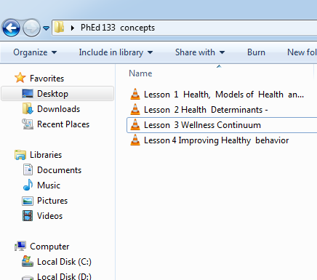

September 21, 2020
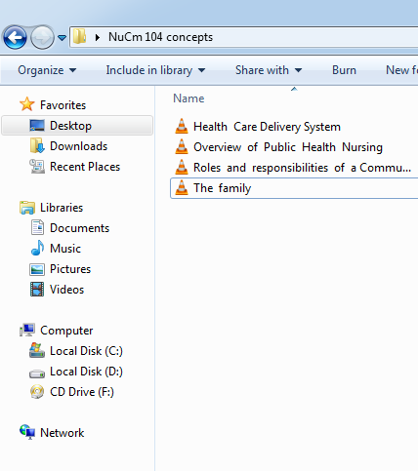
- Recorded lecture- discussion( audio) of the concepts. Convert powerpoint to windows media video.

September 28, 2020
1. Recorded lecture- discussion( audio) of the concepts. Convert powerpoint to windows media video.
