WORK FROM HOME

October 16, 2020:
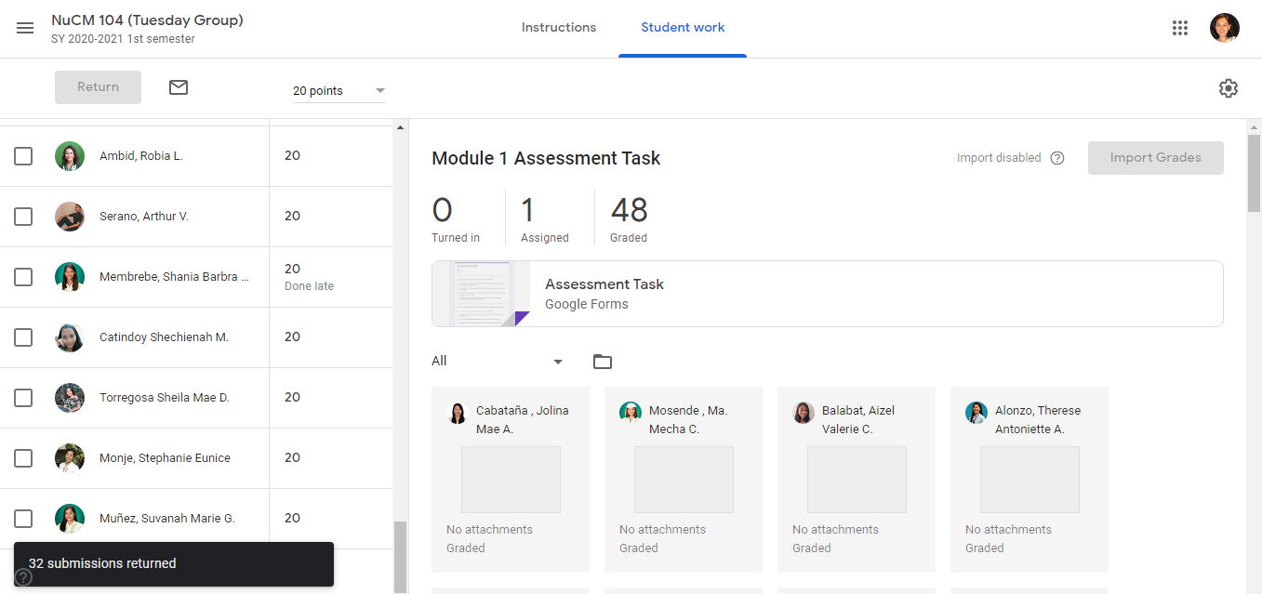
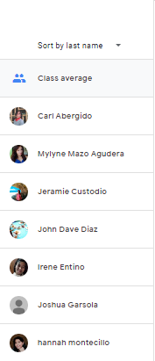
Check the students’ output of NuCM 104
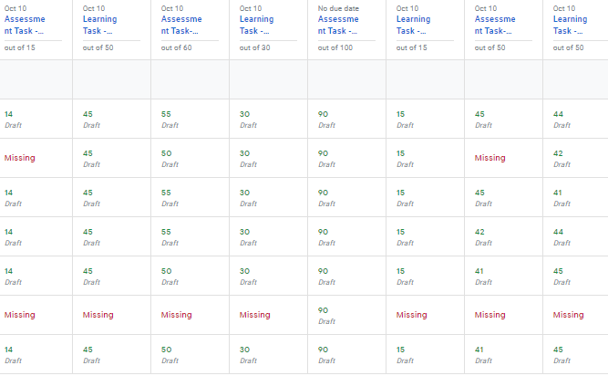

Checked the students’ output of module 1 lessons 1 to 4 of PhEd 133.

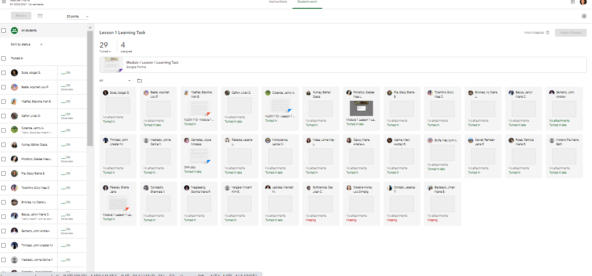
Checked the students’ output of module 1 of NuCM 113

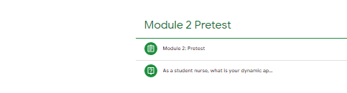

Uploaded Module 2 in the google classroom

