Module No. 1
CORE CONCEPTS IN PHARMACOLOGY

LESSON OVERVIEW:
More drugs are being administered to consumers than ever before. History tells us on how ancient people discover and utilizes plants to relieve symptoms of disease. Significant events in the history of pharmacology opens the minds of learners and appreciate the changes of what we have now –the advancement of medicines.

The human body works through a complicated series of chemical reactions and processes. When drugs are administered, the body begins a sequence of processes designed to handle the new chemicals. These processes, which involve breaking down and eliminating the drugs, in turn affect the body’s complex series of chemical reactions. In clinical practice, health care providers focus on how chemicals act on living organisms.

LEARNING OUTCOMES:
Upon completion of this module, you will be able to:
- Explain the history of Pharmacology.
- Deﬁne the word pharmacology.
- Outline the steps involved in developing and approving a new drug.
- Describe the federal controls on drugs that have abuse potential.
- Differentiate between generic and brand-name drugs, over-the-counter and prescription drugs.
- Explain the beneﬁts and risks associated with the use of over-the-counter drugs.

POWER WORDS!

Pharmacology Drug Pharmacodynamics Pharmacokinetics Pharmacotherapeutics

Pharmacognosy Toxicology Pharmacoeconomics Pharmacovigilance Receptor

Prototype Drugs
READINESS TEST:

DISCUSSION

- HISTORY OF PHARMACOLOGY

The story of pharmacology is rich and exciting, filled with accidental discoveries and landmark events. Its history likely began when a human first used a plant to relieve symptoms of disease. One of the oldest forms of healthcare, herbal medicine has been practiced in virtually every culture dating to antiquity. The Babylonians recorded the earliest surviving “prescriptions” on clay tablets in 3000 B.C. At about the same time, the Chinese recorded the Pen Tsao (Great Herbal), a 40-volume compendium of plant remedies dating to 2700 B.C. The Egyptians followed in 1500 B.C. by archiving their remedies on a document known as Eber’s Papyrus.

Little is known about pharmacology during the Dark Ages. Although it is likely that herbal medicine continued to be practiced, few historical events related to this topic were recorded. Pharmacology, and indeed medicine, could not advance until the discipline of science was eventually viewed as legitimate by the religious doctrines of the era.

The first recorded reference to the word pharmacology was found in a text entitled, “Pharmacologia sen Manuductio and Materiam Medicum”, by Samuel Dale in 1693. Before this date, the study of herbal remedies was called “Materia Medica”, a term that persisted into the early 20th century.

Although the exact starting date is obsecure, modern pharmacology is thought to have begun in the early 800s. At that time, chemists were making remarkable progress in isolating specific substances from complex mixtures. This enabled chemists to isolate the active agents of morphine, colchicine, curare, cocaine, and other early pharmacological agents from their natural products. Pharmacologists could then study their effects in animals more precisely, using standardized amounts. Indeed, some of the early researchers used themselves as test subjects. Frederich Serturner, who first isolated morphine from opium in 1805, injected himself and three friends with a huge dose (199mg) of his new product. He and his cohorts suffered acute morphine intoxication for several days afterward.

Pharmacology as a distinct discipline was officially recognized when first department of pharmacology was established in Estonia in 1847.John Jacob Abel, who is considered the father of American pharmacology due to his many contributions to the field, founded the first pharmacology department in the United States at the University of Michigan in 1890.

In the 20th century, the pace of change in all areas of medicine became exponential. Pharmacologists no longer needed to rely upon the slow, laborious process of isolating active agents from scarce natural products; they could synthesize and tested in a relatively short time. More importantly, it became possible to understand how drugs produced their effects, down to their molecular mechanism of action.

The current practice of pharmacology is extremely complex and far advanced compared with its early, primitive history. The nurses and other health professionals who practice it, however, must never forget its early roots: the application of products to relieve human suffering. Whether it is a substance extracted from the pacific yew tree, one isolated from a fungus, or one created totally in laboratory, the central purpose of pharmacology is to focus on the patient and to improve the quality of life.

- PHARMACOLOGICAL CONCEPTS

Pharmacology is an expensive subject ranging from understanding how drugs are administered, to where they travel in the body, to the actuals responses produced. To learn the discipline well, student nurses need a firm understanding of concepts from various foundation areas such as anatomy and physiology, chemistry, microbiology and pathophysiology.

The word pharmacology is derived from two Greek words, pharmakon, which means “medicine drug”, and logos, which means “study”. Thus, pharmacology is most simply defined as the study of medicines.

Pharmacology
- It the study of the manner in which the function of living system is affected by chemical agents/drugs
- Science concerned with history, sources, physical & chemical properties of drugs & the way in which drug affects living system.
- It is the study of drugs (chemicals) that alter functions of living organisms.

Drug
- A chemical agent capable of producing biological responses within the body.
- Any product/substances used to modify/explore physiologic system/pathologic states for the benefit of the patient according to World Health Organization (WHO).

Drug Therapy
- It is also called pharmacotherapy.
- The uses of drugs to prevent, diagnose, or treat signs, symptoms, and disease processes.
- When prevention or cure is not a reasonable goal, relief of symptoms can greatly improve quality of life.
- Drugs given for therapeutic purposes are usually called medications.

Subdivisions of Pharmacology:
      - Pharmacodynamics – study of the biochemical & physiological effects of drugs & mechanisms of action; what the drug does to the body.

      - Pharmacokinetics – deals with the absorption, distribution, biotransformation & excretion of drugs; what the body does to the drug

      - Pharmacotherapeutics – study of drugs used in the diagnosis, prevention, suppression, & treatment of diseases; deals with beneficial effects of the drugs (medicines)

      - Pharmacognosy – study of drugs in their original unaltered state; origin of drugs, source of drugs; ex: penicillin from penicillium (fungi)

      - Toxicology – study of biologic toxins: study of poison & its effects deals with deleterious effects of physical & chemical agents (including drugs) in human

Other Terminologies
- Pharmacoeconomics – the study of relationship of drugs & economics
- Pharmacovigilance – the science of collecting, researching, analyzing, & evaluating set of information about adverse drug effects.
- Receptor – a component of the cell that interacts with drug, initiating a chain of biochemical events leading to drugs’ observed effects
- Prototype Drugs – individual drugs that represent groups of drugs. May be the first drugs of this group to be developed (e.g., penicillin for antibiotics, morphine for opioid analgesics)

- FUNDAMENTAL PRINCIPLES OF PHARMACOLOGY

It’s important to understand the difference between pharmacokinetics (drug movement) and pharmacodynamics (drug action).

  - Pharmacokinetics
- It is the study of what the body does to the drug. Pharmacokinetics involves the study of absorption, distribution, metabolism (biotransformation), and excretion of drugs. In clinical practice, pharmacokinetics considerations include the onset of drug action, drug half-life, timing of the peak effect, duration of drug effects, metabolism or biotransformation of the drug, and the site of excretion.

- Absorption
- To reach reactive tissues, a drug must ﬁrst make its way into the circulating ﬂuids of the body. Absorption refers to what happens to a drug from the time it is introduced to the body until it reaches the circulating ﬂuids and tissues. Drugs can be absorbed from many different areas in the body: through the GI tract either orally or rectally, through mucous membranes, through the skin, through the lung, or through muscle or subcutaneous tissues.

Absorption Processes
- Drugs can be absorbed into cells through various processes, which include passive diffusion, active transport, and ﬁltration. Passive diffusion is the major process through which drugs are absorbed into the body. Passive diffusion occurs across a concentration gradient. When there is a greater concentration of drug on one side of a cell membrane, the drug will move through the membrane to the area of lower concentration. This process does not require any cellular energy. It occurs more quickly if the drug molecule is small, is soluble in water and in lipids (cell membranes are made of lipids and proteins, and has no electrical charge that could repel it from the cell membrane.
- Unlike passive diffusion, active transport is a process that uses energy to actively move a molecule across a cell membrane. The molecule may be large, or it may be moving against a concentration gradient. This process is not very important in the absorption of most drugs, but it is often a very important process in drug excretion in the kidney. Filtration involves movement through pores in the cell membrane, either down a concentration gradient or as a result of the pull of plasma proteins (when pushed by hydrostatic, blood, or osmotic pressure). Filtration is another process the body commonly uses in drug excretion.
- Bioavailability and Bioequivalent - portion of a dose that reaches the systemic circulation and is available to act on body cells. IV administration is 100% bioavailable

- Factors That Affect Absorption
      - Administration route of the drug
      - Ability of medications to dissolve
      - Food or fluids administered with the drug
      - Body Surface Area (BSA)
      - Status of the absorptive surface
      - Rate of blood flow to the small intestine
      - Lipid Solubility of Med
      - Status of GI motility

- Distribution
- Distribution involves the movement of a drug to the body’s tissues. As with absorption, factors that can affect distribution include the drug’s lipid solubility and ionization and the perfusion of the reactive tissue.

- For example, tissue perfusion is a factor in treating a patient with diabetes who has a lower-leg infection and needs antibiotics to destroy the bacteria in the area. In this case, systemic drugs may not be effective because part of the disease process involves changes in the vasculature and decreased blood ﬂow to some areas, particularly the lower limbs. If there is not adequate blood ﬂow to the area, little antibiotic can be delivered to the tissues, and little antibiotic effect will be seen.

- In the same way, patients in a cold environment may have constricted blood vessels (vasoconstriction) in the extremities, which would prevent blood ﬂow to those areas. The circulating blood would be unable to deliver drugs to those areas, and the patient would receive little therapeutic effect from drugs intended to react with those tissues.

- Many drugs are bound to proteins and are not lipid soluble. These drugs cannot be distributed to the central nervous system (CNS) because of the effective blood–brain barrier, which is highly selective in allowing lipidsoluble substances to pass into the CNS.

- Protein-binding - Protein-binding allows only a limited amount of the drug to be available for use. The rest is bound to protein. Clients with low albumin levels will have higher levels of circulating drugs, and are at risk for drug toxicity.

- Water soluble vs. fat soluble - Since the body is largely made up of water, drugs that are highly water soluble will have higher concentrations in the blood. Fat soluble drugs are attracted to the low water content of tissue and will have a low concentration in the blood.

- Blood-brain barrier - The blood-brain barrier prevents distribution of certain drugs into the brain (ie. dopamine). The blood–brain barrier is a protective system of cellular activity that keeps many things (e.g., foreign invaders, poisons) away from the CNS. Drugs that are highly lipid soluble are more likely to pass through the blood–brain barrier and reach the CNS. Drugs that are not lipid soluble are not able to pass the blood–brain barrier. This is clinically signiﬁcant in treating a brain infection with antibiotics. Almost all antibiotics are not lipid soluble and cannot cross the blood–brain barrier. Effective antibiotic treatment can occur only when the infection is severe enough to alter the blood–brain barrier and allow antibiotics to cross. Although many drugs can cause adverse CNS effects, these are often the result of indirect drug effects and not the actual reaction of the drug with CNS tissue. For example, alterations in glucose levels and electrolyte changes can interfere with nerve functioning and produce CNS effects such as dizziness, confusion, or changes in thinking ability.

- Placenta and Breast Milk – Many drugs readily pass through the placenta and affect the developing fetus in pregnant women. As stated earlier, it is best not to administer any drugs to pregnant women because of the possible risk to the fetus. Drugs should be given only when the beneﬁt clearly outweighs any risk. Many other drugs are secreted into breast milk and therefore have the potential to affect the neonate. Because of this possibility, the nurse must always check the ability of a drug to pass into breast milk when giving a drug to a breast-feeding mother.

- Areas of rapid distribution: heart, liver, kidneys, brain. Organs with an extensive blood supply, such as the heart, liver, kidneys and brain, will distribute drugs rapidly. Those with decreased blood supply, such as muscle, skin, and fat, will distribute drugs more slowly.

- The areas of slow distribution are as follows: muscle, skin, fat.

- Metabolism (Biotransformation)
- The biologic transformation of a drug into an inactive metabolite, a more soluble compound, or a more potent metabolite.
      - Liver (main organ)
      - Kidneys
      - Lungs
      - Plasma
      - Intestinal mucosa

- The body is well prepared to deal with a myriad of foreign chemicals. Enzymes in the liver, in many cells, in the lining of the GI tract, and even circulating in the body detoxify foreign chemicals to protect the fragile homeostasis that keeps the body functioning. Almost all of the chemical reactions that the body uses to convert drugs and other chemicals into nontoxic substances are based on a few processes that work to make the chemical less active and more easily excreted from the body.

- The liver is the most important site of drug metabolism, or biotransformation, the process by which drugs are changed into new, less active chemicals. Think of the liver as a sewage treatment plant. Everything that is absorbed from the GI tract ﬁrst enters the liver to be “treated.”The liver detoxiﬁes many chemicals and uses others to produce needed enzymes and structures.

  - Delayed drug metabolism results in:
      - Accumulation of drugs
      - Prolonged action of the drugs
        - Delayed drug metabolism causes a build-up of drugs in the system and creates a prolonged action. If drug metabolism is stimulated, the drug is used up more quickly and has a decreased effect.

  - Stimulating drug metabolism causes:
      - Diminished pharmacologic effects

- Excretion
- The elimination of drugs from the body. It is the removal of a drug from the body. The skin, saliva, lungs, bile, and feces are some of the routes used to excrete drugs. The kidneys, however, play the most important role in drug excretion.

- Drugs that have been made water soluble in the liver are often readily excreted from the kidney by glomerular ﬁltration—the passage of water and water-soluble components fromthe plasma into the renal tubule. Other drugs are secreted or reabsorbed through the renal tubule by active transport systems. The active transport systems that move the drug into the tubule often do so by exchanging it for acid or bicarbonate molecules. Therefore the acidity of urine can play an important role in drug excretion. This concept is important to remember when trying to clear a drug rapidly from the system or trying to understand why a drug is being given at the usual dose but is reaching toxic levels in the system. One should always consider the patient’s kidney function and urine acidity before administering a drug. Kidney dysfunction can lead to toxic levels of a drug in the body because the drug cannot be excreted.
      - Kidneys (main organ)
      - Liver
      - Bowel
        - Biliary excretion
        - Enterohepatic circulation
      - Most drugs are eliminated from the body in the urine.
      - The liver also contributes to drug excretion.
      - With biliary excretion, drugs are taken up by the liver, released into bile, and eliminated in the feces.
      - With enterohepatic recirculation, drugs in the bile are reabsorbed into the bloodstream, returned to the liver, and secreted a second time into the bile.
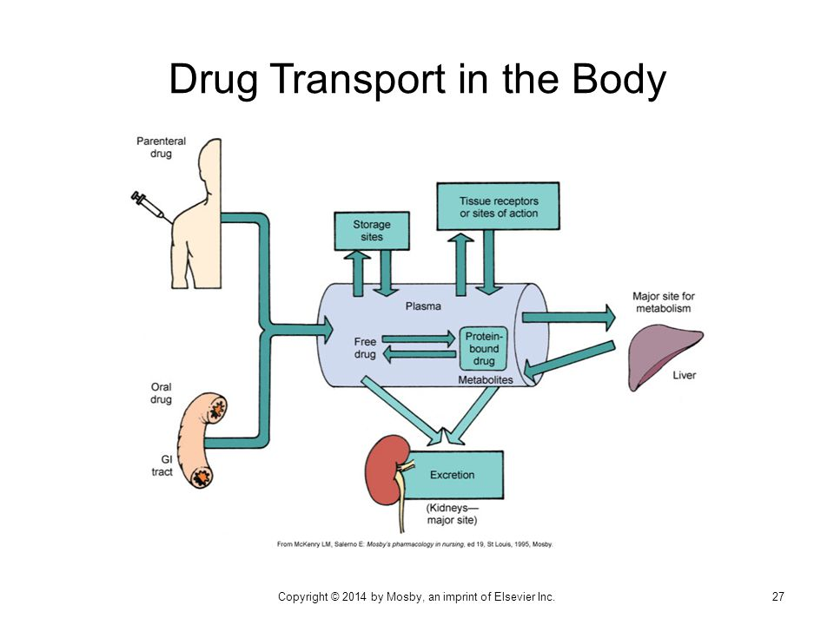

  - Pharmacodynamics
- It is the science dealing with interactions between the chemical components of living systems and the foreign chemicals, including drugs that enter those systems.
- All living organisms function by a series of complicated, continual chemical reactions.
- When a new chemical enters the system, multiple changes in and interferences with cell functioning may occur. To avoid such problems, drug development works to provide the most effective and least toxic chemicals for therapeutic use.

Drugs usually work in one of four ways:
- To replace or act as substitutes for missing chemicals.
- To increase or stimulate certain cellular activities.
- To depress or slow cellular activities.
- To interfere with the functioning of foreign cells, such as invading microorganisms or neoplasms. (Drugs that act in this way are called chemotherapeutic agents.)

Drugs can act in several different ways to achieve these results.

Mechanism of Action
- Ways in which a drug can produce a therapeutic effect
- The effects that a particular drug has depends on the cells or organ targeted by the drug
- Once the drug hits its “site of action” it can modify the rate at which a cell or tissue functions
- Receptor Interaction
- Enzyme Interaction
- Non-Specific Interaction

1. Receptor Interaction
- Drug structure is essential
- Involves the selective joining of drug molecule with a reactive site on the cell surface that elicits a biological effect
- Receptor is the reactive site on a cell or tissue
- Once the substance binds to and interacts with the receptor, a pharmacologic response is produced

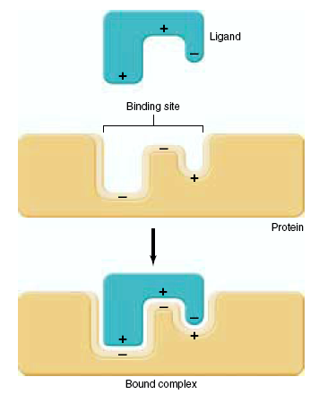

- Affinity- degree to which a drug binds with a receptor
- The drug with the best “fit” or affinity will elicit the best response
- Drug can mimic body’s endogenous substances that normally bind to receptor site
- Drugs that bind to receptors interact with receptors in different ways to either block or elicit a response
- Agonist
  - Drug binds to receptor-there is a response (Adrenergic Agents)
- Antagonist
  - drug binds to receptor-no response
  - prevents binding of agonists (Alpha & Beta Blockers)

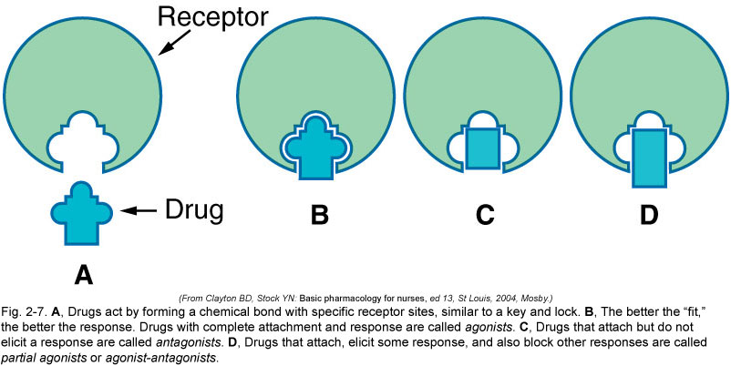

Drug Receptor interaction
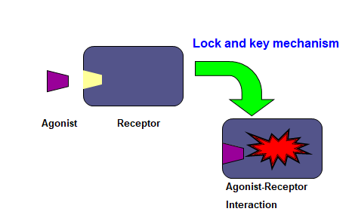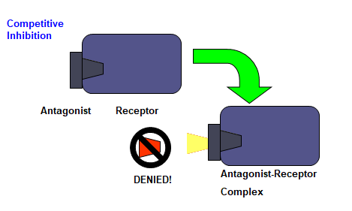

Enzyme Interaction
- Enzymes - substances that catalyze nearly every biochemical reaction in a cell
- Drugs can interact with enzyme systems to alter a response
- Inhibits action of enzymes-enzyme is “fooled” into binding to drug instead of target cell
- Protects target cell from enzyme’s action (ACE Inhibitors)

Non-Specific Interaction
- Not involving a receptor site or alteration in enzyme function
- Main site of action is cell membrane or cellular process
- Drugs will physically interfere or chemically alter cell process
- Final product is altered causing defect or cell death
- Cancer drugs, Antibiotics

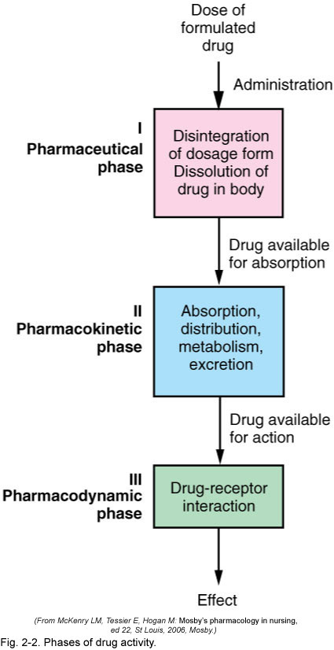

Half-Life
- The half-life of a drug is the time it takes for the amount of drug in the body to decrease to one half of the peak level it previously achieved. For instance, if a patient takes 20 mg of a drug with a half-life of 2 hours, 10 mg of the drug will remain 2 hours after administration. Two hours later, 5 mg will be left (one half of the previous level); in 2 more hours, only 2.5 mg will remain. This information is important in determining the appropriate timing for a drug dose or determining the duration of a drug’s effect on the body.

- The absorption rate, the distribution to the tissues, the speed of biotransformation, and how fast a drug is excreted are all taken into consideration when determining the half-life of the drug. The half-life that is indicated in any drug monograph is the half-life for a healthy person. Using this information, one can estimate the half-life of a drug for a patient with kidney or liver dysfunction (which could prolong the biotransformation and the time required for excretion of a drug), allowing the prescriber to make changes in the dosing schedule.

- The timing of drug administration is important to achieve the most effective drug therapy. Nurses can use their knowledge of drug half-life to explain the importance of following a schedule of drug administration in the hospital or at home.

- The timing of drug administration is important to achieve the most effective drug therapy. Nurses can use their knowledge of drug half-life to explain the importance of following a schedule of drug administration in the hospital or at home.

  - Pharmacotherapeutics

Types of Therapies
- Acute therapy - drugs are used to sustain life or treat disease
- Maintenance therapy - drugs are used to prevent the progression of chronic diseases, such as hypertension
- Supplemental therapy - drugs supply substances not available to the body, such as insulin for diabetic clients
- Palliative therapy - are used to maintain comfort
- Supportive therapy - helps maintain body functions
- Prophylactic drugs - help prevent illness and have scientific evidence to support their use
- Empiric drugs are used based on past experience with their actions rather than scientific evidence.

- INTRODUCTION TO DRUGS AND DRUG ADMINISTRATION
Sources of Drugs
- Drugs are available from varied sources, both natural and synthetic. Natural sources include plants, animals, and inorganic compounds.

A. Natural Sources
- Chemicals that might prove useful as drugs can come from many natural sources, such as plants, animals, or inorganic compounds. To become a drug, a chemical must have a demonstrated therapeutic value or efﬁcacy without severe toxicity or damaging properties.

1. Plants
- Plants and plant parts have been used as medicines since prehistoric times. Even today, plants are an important source of chemicals that are developed into drugs. For example, digitalis products used to treat cardiac disorders and various opiates used for sedation are still derived from plants.
- Drugs also may be processed using a synthetic version of the active chemical found in a plant. An example of this type of drug is dronabinol (Marinol), which contains the active ingredient delta-9-tetrahydrocannabinol found in marijuana. This drug helps to prevent nausea and vomiting in cancer patients but does not have all of the adverse effects that occur when the marijuana leaf is smoked. Marijuana leaf is a controlled substance with high abuse potential and has no legal or accepted medical use. The synthetic version of the active ingredient allows for an accepted form to achieve the desired therapeutic effect in cancer patients.
- Ingestion of a plant-derived food can sometimes lead to a drug effect. For instance,the body converts natural licorice to a false aldosterone—a hormone found in the body—resulting in ﬂuid retention and hypokalemia or low serum potassium levels if large amounts of licorice are eaten. However, people seldom think of licorice as a drug.
- Finally, plants have become the main component of the growing alternative therapy movement.

2. Animal Products
- Animal products are used to replace human chemicals that fail to be produced because of disease or genetic problems. Until recently, insulin for treating diabetes was obtained exclusively from the pancreas of cows and pigs. Now genetic engineering—the process of altering DNA—permits scientists to produce human insulin by altering Escherichia coli bacteria, making insulin a better product without some of the impurities that come with animal products.
- Thyroid drugs and growth hormone preparations also may be obtained from animal thyroid and hypothalamic tissues. Many of these preparations are now created synthetically, however, and the synthetic preparations are considered to be purer and safer than preparations derived from animals.

3. Inorganic Compounds
- Salts of various chemical elements can have therapeutic effects in the human body. Aluminum, ﬂuoride, iron, and even gold are used to treat various conditions. The effects of these elements usually were discovered accidentally when a cause–effect relationship was observed.

B. Synthetic Sources
- Today, many drugs are developed synthetically after chemicals in plants, animals, or the environment have been tested and found to have therapeutic activity. Scientists use genetic engineering to alter bacteria to produce chemicals that are therapeutic and effective. Other technical advances allow scientists to alter a chemical with proven therapeutic effectiveness to make it better. Sometimes, a small change in a chemical’s structure can make that chemical more useful as a drug—more potent, more stable, less toxic.
- These technological advances have led to the development of groups of similar drugs, all of which are derived from an original prototype, but each of which has slightly different properties, making a particular drug more desirable in a speciﬁc situation.
- Alterations in the chemical rings or attachments to that structure make it possible for some of these drugs to be absorbed orally, whereas others must be given parenterally. Some of these drugs cause severe toxic effects (e.g., renal toxicity), but others do not.

- DRUGS AND FACTORS AFFECTING THEIR ACTIONS

Drug Nomenclature
1. Trade/Brand/Propriety Name
  - given by the drug company that developed drug
  - followed by symbol R or TM, 1st letter is capitalized

2. Generic Name/Non-Property Name
  - original designation given to the drug
  - universally accepted & not capitalized; before drug becomes official, used in all countries
  - protected by law (patent)

3. Chemical Name
  - atomic/molecular structure of drug

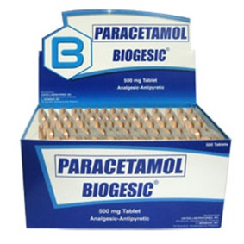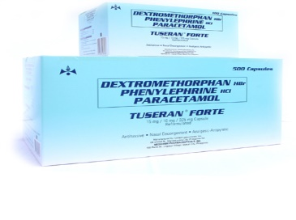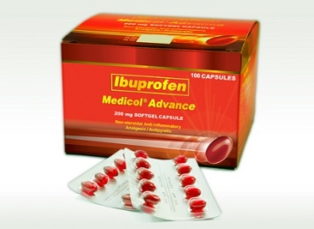

An approved drug is given a brand name (trade name) by the pharmaceutical company that developed it. The generic name of a drug is the original designation that the drug was given when the drug company applied for the approval process. Chemical names are names that reflect the chemical structure of a drug.

Medication Orders
Prescription (Px)
- Order written authorizing patient to receive medication. Prescriptions taken to pharmacy whereby the pharmacist dispenses the drug.
Prescriptions
Written, legible prescriber’s order includes:
- Patient name
- Date and time
- Drug name
- Dose
- Route
- Time or Frequency of drug is given
- Signature of physician
- Any special instructions

Types of Medication Orders
- STAT order: needed immediately
- Single order: given only once
- PRN order: given as needed
- Routine orders: given within 2 hours of being written and carried out on schedule
- Standing order: written in advance carried out under specific circumstances.

Principles of Drug Administration
- Medications used to treat patient. are dispensed by the pharmacy
- Medications are prescribed only by physicians, podiatrists and dentists and are to be in writing
- Medications are given by the person who prepared them
- Medications are not to be left at the bedside since it can’t be taken correctly
- Narcotics and other controlled drugs are kept in locked cabinets
- Check medication orders before giving drugs
- Avoid distractions or interruptions when preparing or administering meds.
- Know about the drugs being given
- Observe the 15 rights of medication administration
- Document after the drug is given
- Do not return loose pills or unused meds to stock containers
- Observe the principles of aseptic technique
  - Wash hands before drug preparation
  - Avoid touching the inside of med container or cups
  - Don’t handle or touch meds
  - Pour pills or tablets into the bottle cover and then transfer them into med glass
- Before preparing meds, verify which patients are instructed nothing by mouth.
- Obtain a complete medication history and look for possible drug interactions among the medIcations.
- Patient education about the drug.

Medication Ticket
- Color coding depends on timing and frequency of drug or on hospital policy

Factors Affecting Drug Actions
- When administering a drug to a patient, the nurse must be aware that the human factor has a tremendous inﬂuence on what actually happens to a drug when it enters the body. No two people react in exactly the same way to any given drug. Even though textbooks and drug guides explain the pharmacodynamics and pharmacokinetics of a drug, it must be remembered that such information usually is based on studies of healthy adult males. Things may be very different in the clinical setting. Consequently, before administering any drug, the nurse must consider a number of factors.

1. Physiological variables
a. Gender
    - Physiological differences between men and women can inﬂuence a drug’s effect. When giving IM injections, for example, it is important to remember that men have more vascular muscles, so the effects of the drug will be seen sooner in men than in women.
    - Women have more fat cells than men do, so drugs that deposit in fat may be slowly released and cause effects for a prolonged period. For example, gas anesthetics have an afﬁnity for depositing in fat and can cause drowsiness and sedation sometimes weeks after surgery. Women who are given any drug should always be questioned about the possibility of pregnancy because, as stated previously, the use of drugs in pregnant women is not recommended unless the beneﬁt clearly outweighs the potential risk to the fetus.Pregnant and lactating women must be advised of the effects of drugs to the fetus

b. Age
  - Age is a factor primarily in children and older adults. Children metabolize many drugs differently than adults do, and they have immature systems for handling drugs. Many drugs come with recommended pediatric doses,and others can be converted to pediatric doses using one of several conversion formulas.
  - Older adults undergo many physical changes that are a part of the aging process. Their bodies may respond very differently in all aspects of pharmacokinetics—less effective absorption, less efﬁcient distribution because of fewer plasma proteins and less efﬁcient perfusion, altered biotransformation or metabolism of drugs because of age-related liver changes, and less effective excretion owing to less efﬁcient kidneys. Many drugs now come with recommended doses for patients who are older. The doses of other drugs also may need to be decreased for the older adult.
  - When administering drugs to a patient at either end of the age spectrum, one should monitor the patient closely for the desired effects. If the effects are not what would normally be expected, one should consider the need for a dose adjustment.

c. Weight
- The recommended dose of a drug is based on drug evaluation studies and is targeted at a 150-pound person. People who are much heavier may require larger doses to get a therapeutic effect from a drug because they have increased tissues to perfuse and increased receptor sites in some reactive tissue. People who weigh less than the norm may require smaller doses of a drug. Toxic effects may occur at the recommended dose if the person is very small.

d. Physiological factors
- Physiological differences such as diurnal rhythm of the nervous and endocrine systems, acid–base balance, hydration, and electrolyte balance can affect the way that a drug works on the body and the way that the body handles the drug. If a drug does not produce the desired effect, one should review the patient’s acid–base and electrolyte proﬁles and the timing of the drug.

e. Pathological factors
- Drugs are usually used to treat disease or pathology. However, the disease that the drug is intended to treat can change the functioning of the chemical reactions within the body and thus change the response to the drug.
- Other pathological conditions can change the basic pharmacokinetics of a drug. For example, GI disorders can affect the absorption of many oral drugs. Vascular diseases and low blood pressure alter the distribution of a drug, preventing it from being delivered to the reactive tissue, thus rendering the drug nontherapeutic. Liver or kidney diseases affect the way that a drug is biotransformed and excreted and can lead to toxic reactions when the usual dose is given.

f. Genetic factors
- Genetic differences can sometimes explain patients’ varied responses to a given drug. Some people lack certain enzyme systems necessary for metabolizing a drug, whereas others have overactive enzyme systems that cause drugs to be broken down more quickly. Still others have differing metabolisms or slightly different enzymatic makeups that alter their chemical reactions and the effects of a given drug.

g. Immunological factors
- People can develop an allergy to a drug. After exposure to its proteins, a person can develop antibodies to a drug. With future exposure to the same drug, that person may experience a full-blown allergic reaction. Sensitivity to a drug can range from mild (e.g., dermatological reactions such as a rash) to more severe (e.g., anaphylaxis, shock, and death).

2. Environmental conditions
- The environment can affect the success of drug therapy. Some drug effects are enhanced by a quiet, cool, nonstimulating environment. For example, sedating drugs are given to help a patient relax or to decrease tension. Reducing external stimuli to decrease tension and stimulation help the drug be more effective. Other drug effects may be inﬂuenced by temperature. For example, antihypertensives that work well during cold, winter months may become too effective in warmer environments, when natural vasodilation may lead to a release of heat that tends to lower the blood pressure. If a patient’s response to a medication is not as expected, look for possible changes in environmental conditions.

3. Psychological factors
- Stress, emotional conflict, anxiety and fear may alter response to drug therapy.
- The patient’s attitude about a drug has been shown to have an effect on how that drug works. A drug is more likely to be effective if the patient thinks it will work than if the patient believes it will not work. This is called the placebo effect.
- The patient’s personality also inﬂuences compliance with the drug regimen. Some people who believe that they can inﬂuence their health actively seek health care and willingly follow a prescribed regimen. These people usually trust the medical system and believe that their efforts will be positive. Other people do not trust the medical system. They may believe that they have no control over their health and may be unwilling to comply with any prescribed therapy. Knowing a patient’s health-seeking history and feelings about health care is important in planning an educational program that will work for that patient. It is also important to know this information when arranging for necessary follow-up procedures and evaluations.

4. Tolerance
- The body may develop a tolerance to some drugs over time. Tolerance may arise because of increased biotransformation of the drug, increased resistance to its effects, or other pharmacokinetic factors. When tolerance occurs, the drug no long causes the same reaction. Therefore, increasingly larger doses are needed to achieve a therapeutic effect. An example is morphine, an opiate used for pain relief. The longer morphine is taken, the more tolerant the body becomes to the drug, so that larger and larger doses are needed to relieve pain. Clinically, this situation can be avoided by giving the drug in smaller doses or in combination with other drugs that may also relieve pain. Cross-tolerance—or resistance to drugs within the same class—may also occur in some situations.

5. Cumulation
- If a drug is taken in successive doses at intervals that are shorter than recommended, or if the body is unable to eliminate a drug properly, the drug can accumulate in the body, leading to toxic levels and adverse effects. This can be avoided by following the drug regimen precisely. In reality, with many people managing their therapy at home, strict compliance with a drug regimen seldom occurs. Some people take all of their medications ﬁrst thing in the morning, so that they won’t forget to take the pills later in the day. Others realize that they forgot a dose and then take two to make up for it. Many interruptions of everyday life can interfere with strict adherence to a drug regimen. If a drug is causing serious adverse effects, review the drug regimen with the patient to ﬁnd out how the drug is being taken, and then educate the patient appropriately.

6. Interactions
- When two or more drugs or substances are taken together, there is a possibility that an interaction can occur, causing unanticipated effects in the body. Alternative therapies, such as herbal products, act as drugs in the body and can cause these same interactions. Certain foods can interact with drugs in much the same way. Usually this is an increase or decrease in the desired therapeutic effect of one or all of the drugs or an increase in adverse effects.

- CLASSIFICATION OF THERAPEUTIC AGENTS AS DRUGS, BIOLOGICS AND ALTERNATIVE THERAPIES

Drugs
- In pharmacology, a drug is "a chemical substance used in the treatment, cure, prevention, or diagnosis of disease or used to otherwise enhance physical or mental well-being."

Therapeutic Actions of Drugs
Drug Type | Description | Examples
Palliative | Relieves the symptoms of a disease but does not affect the disease itself. | Morphine sulfate, aspirin for pain
Curative | Cures a disease or condition. | Penicillin for infection
Supportive | Supports body function until other treatments or the body’s response can take over. | Norepinephrine bitartrate for low blood pressure; aspirin for high body temperature
Substitutive | Replaces body fluids or substances. | Thyroxine for hypothyroidism, insulin for diabetes mellitus
Chemotherapeutic | Destroys malignant cells. | Busulfan for leukemia
Restorative | Returns the body to health. | Vitamin, mineral supplements

Biologics
- It includes a wide range of medicinal product created by biological processes and it can be composed of sugars, proteins, or nucleic acids.
- They are used to stimulate the production of antibodies, to provide preformed antibodies to facilitate an immune reaction, or to react specifically with the toxins produced by an invading pathogen.
- It is isolated from a variety of natural sources - human, animal and in some jurisdictions, biologics are regulated in a different manner than are drugs and medical devices.
- Examples are the following: vaccines, blood and blood components, allergenics, somatic cells, gene therapy, tissues, and recombinant proteins.

Alternative Therapies
- Another aspect of the increasing self-care movement is the rapidly growing alternative or herbal therapies market.
- Herbal or alternative therapies are found in ancient records and have often been the basis for discovery of an active ingredient that is later developed into a regulated medication.
- Today, alternative therapies can also include nondrug measures such as imaging and relaxation.
- Examples include naturopathy, chiropractic, herbalism, traditional Chinese medicine, Unani, Ayurveda, meditation, yoga, biofeedback, hypnosis, homeopathy, acupuncture, and diet-based therapies.
- Frequently grouped with complementary medicine - refers to the same interventions used in conjunction with mainstream techniques under the umbrella term complementary and alternative medicine, or CAM.

- DRUG CLASSES AND SCHEDULES

Controlled Substances and Drug Schedules
- Some drugs are frequently abused or have a high potential for addiction. Technically, addiction refers to the overwhelming feeling that drives someone to use a drug repeatedly. Dependence is a related term, often defines as a physiological or psychological need for a substance. Physical dependence refers to an altered physical condition caused by the nervous system adapting to repeated drug use. In this case, when the drug is no longer available, the individual expresses physical signs of discomfort known as withdrawal. In contrast, when an individual is psychologically dependent, there are few signs of physical discomfort when the drug is withdrawn; however, the individual feels an intense compelling desire to continue drug use.

- Drugs that cause dependency are restricted for use in situations of medical necessity, it at all. According to law, drugs that have a significant potential for abuse are placed into five categories called schedules. These scheduled drugs are classified according to their potential for abuse: Schedule I drugs have the highest potential for abuse, and Schedule V drugs have the lowest potential for abuse. Schedule I drugs have little to no therapeutic value or are intended for research purposes only. Drugs in the other four schedules may be dispensed only in cases when therapeutic value has been determined. Schedule V is the only category in which some drugs may be dispensed without a prescription, because the quantities of the controlled drug are so low that the possibility of causing dependence is extremely remote.

U.S. Drug Schedules and Examples
Drug Schedule | Abuse Potential | Medical Use | Dependency Potential |  | Examples | Therapeutic Use
Drug Schedule | Abuse Potential | Medical Use | Physical | Psychological | Examples | Therapeutic Use
I | Highest | None | High | High | heroin, LSD, marijuana, and methaqualone | limited or no therapeutic use
II | High | Accepted | High | High | morphine, PCP, cocaine, methadone, and methamphetamine, | Use therapeutically with prescription; some drugs no longer used
III | Moderate | Accepted | Moderate | High | Anabolic steroids, codeine and hydrocodone with aspirin or Tylenol, and some barbiturates | Used therapeutically with prescriptions
IV | Lower | Accepted | Lower | Lower | Farvon, Talwin, Equanil, Valium and Xanax | Used therapeutically with prescriptions
V | Lowest | Accepted | Lowest | Lowest | Over-the-counter cough medicines with codeine | Used therapeutically without prescription

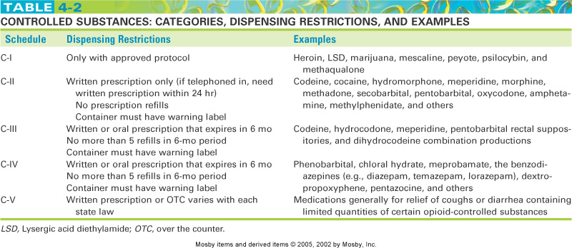

- OVER THE COUNTER MEDICATION AND PRESCRIPTION

- DRUG INFORMATION RESOURCES

- LEGAL REGULATION OF DRUGS

- FACTORS INFLUENCING DRUG EFFECTS

Drug Tolerance - Decreased response to drug due to repeated administration

Drug Dependence
- Reliance or need to take drug
- With physical or emotional dependence when withdrawn

Addiction
- Biochemical changes in the body due to drug dependence

Habituation
- Emotional reliance on drug to maintain sense of well-being

Drug Interactions
- When two or more drugs or substances are taken together, there is a possibility that an interaction can occur, causing unanticipated effects in the body. Alternative therapies, such as herbal products, act as drugs in the body and can cause these same interactions. Certain foods can interact with drugs in much the same way. Usually this is an increase or decrease in the desired therapeutic effect of one or all of the drugs or an increase in adverse effects.

- Drug–Drug or Drug–Alternative Therapy Interactions
- Clinically signiﬁcant drug–drug interactions occur with drugs that have small margins of safety. If there is very little difference between a therapeutic dose and a toxic dose of the drug, interference with the drug’s pharmacokinetics or pharmacodynamics can produce serious problems. For example, drug–drug interactions can occur in the following situations:
- At the site of absorption
- Drug distribution
- During biotransformation
- During excretion
- At the site of action

- Whenever two or more drugs are being given together, ﬁrst consult a drug guide for a listing of clinically signiﬁcant drug– drug interactions. Sometimes problems can be avoided by staggering the administration of the drugs or adjusting their doses.

- Drug–Food Interactions
- For the most part, a drug–food interaction occurs when the drug and the food are in direct contact in the stomach. Some foods increase acid production, speeding the breakdown of the drug molecule and preventing absorption and distribution of the drug. Some foods chemically react with certain drugs and prevent their absorption into the body.
- The antibiotic tetracycline cannot be taken with iron products for this reason. Tetracycline also binds with calcium to some extent and should not be taken with foods or other drugs containing calcium. Grapefruit juice has been found to affect liver enzyme systems for up to 48 hours after it has been ingested. This can result in increased or decreased serum levels of certain drugs.
- Many drugs come with the warning that they should not be combined with grapefruit juice. This drug–food interaction does not take place in the stomach, so the grapefruit juice needs to be avoided the entire time the drug is being used, not just while the drug is in the stomach.
- In most cases, oral drugs are best taken on an empty stomach. If the patient cannot tolerate the drug on an empty stomach, the food selected for ingestion with the drug should be something that is known not to interact with it. Drug monographs usually list important drug–food interactions and give guidelines for avoiding problems and optimizing the drug’s therapeutic effects.

- Drug–Laboratory Test Interactions
- As explained previously, the body works through a series of chemical reactions. Because of this, administration of a particular drug may alter results of tests that are done on various chemical levels or reactions as part of a diagnostic study. This drug–laboratory test interaction is caused by the drug being given and not necessarily by a change in the body’s responses or actions. Keep these interactions in mind when evaluating a patient’s diagnostic tests. If one test result is altered and does not ﬁt in with the clinical picture or other test results, consider the possibility of drug–laboratory test interference. For example, dalteparin (Fragmin), a low-molecular-weight heparin used to prevent deep vein thrombosis after abdominal surgery, may cause increased levels of the liver enzymes aspartate aminotransferase (AST) and alanine aminotransferase (ALT) with no injury to liver cells or hepatitis.

Synergistic effect- drugs create a greater effect when combined than each one alone. Narcotics & Antihistamines = sedation. Not always undesirable. Physician may combine meds to create an interaction that will have beneficial effects (Vasodilators & diuretics to control high BP).

Antagonistic effect - Drugs are antagonistic when their combined effect is less than each of them alone.

Incompatibility - Drugs are incompatible when combining them causes chemical deterioration of one or both

Iatrogenic Responses – Treatment induced.
- Examples:
- Dermatologic-rash, hives, acne
- Renal
- Blood Dyscrasias- Destruction of blood cells
- Hepatic Toxicity-Elevated liver enzymes

Medication Dose Responses
- Repeated, regular, fixed doses are required to achieve a constant therapeutic concentration of a med because a portion of med is always being excreted
- Peak & Trough levels

- TOXIC EFFECTS OF DRUGS

Toxicology
- The study of poisons and unwanted responses to therapeutic agents
- Clinical toxicology provides information on the care of the poisoned client.
- The nurse the must prioritize the care of the poisoned client:
- preserve vital functions
- prevent absorption or increase rate of elimination
* ipecac
* activated charcoal
* cathartics

Common Poisons and Antidotes
Poison | Antidote
acetaminophen | acetylcysteine
Organophosphates (e.g. insecticides) | Atropine
Tricyclic antidepressants, quinidine | Sodium bicarbonate
Calcium channel blockers | IV calcium
Iron salts | deferoxamine (Desferal)
digoxin and other cardiac glycosides | digoxin antibodies (Digibind)
Ethylene glycol (automotive antifreeze solution), methanol | Ethanol (same as alcohol used for drinking), given IV
Benzodiazepines | flumazenil
Beta-blockers | glucagon
Opiate/opioid drugs | naloxone (Narcan)
Carbon monoxide (by inhalation) | Oxygen (high – concentration)

COMPLEMENTARY AND ALTERNATIVE THERAPIES

Ten (10) Herbal Medicines in the Philippines approved by the Department of Health (DOH)
- Akapulko (Cassia alata)
  - It also known as "bayabas-bayabasan" and "ringworm bush" in English, this herbal medicine is used to treat ringworms and skin fungal infections.

- Ampalaya (Momordica charantia)
  - Known as "bitter gourd" or "bitter melon" in English, it most known as a treatment of diabetes (diabetes mellitus), for the non-insulin dependent patients.

- . Bawang (Allium sativum)
  - It is popularly known as "garlic", it mainly reduces cholesterol in the blood and hence, helps control blood pressure.

- Bayabas (Psidium guajava)
  - Known as "guava" in English. It is primarily used as an antiseptic, to disinfect wounds. Also, it can be used as a mouth wash to treat tooth decay and gum infection.

- Lagundi (Vitex negundo)
  - It is known in English as the "5-leaved chaste tree". It's main use is for the relief of coughs and asthma.

- Niyog-niyogan (Quisqualis indica L.)
  - It is a vine known as "Chinese honey suckle". It is effective in the elimination of intestinal worms, particularly the Ascaris and Trichina. Only the dried matured seeds are medicinal -crack and ingest the dried seeds two hours after eating (5 to 7 seeds for children & 8 to 10 seeds for adults). If one dose does not eliminate the worms, wait a week before repeating the dose.

- Sambong (Blumea balsamifera)
  - The english name: Blumea camphora. A diuretic that helps in the excretion of urinary stones. It can also be used as an edema.

- Tsaang Gubat (Ehretia microphylla Lam.)
  - Prepared like tea, this herbal medicine is effective in treating intestinal motility and also used as a mouth wash since the leaves of this shrub has high fluoride content.

- Ulasimang Bato | Pansit-Pansitan (Peperomia pellucida)
  - It is effective in fighting arthritis and gout. The leaves can be eaten fresh (about a cupful) as salad or like tea. For the decoction, boil a cup of clean chopped leaves in 2 cups of water. Boil for 15 to 20 minutes. Strain, let cool and drink a cup after meals (3 times day).

- Yerba Buena (Clinopodium douglasii)
  - It is commonly known as Peppermint, this vine is used as an analgesic to relive body aches and pain. It can be taken internally as a decoction or externally by pounding the leaves and applied directly on the afflicted area.

- 15 RIGHTS OF MEDICATION ADMINISTRATION

The 15 Rights of Medication Administration
- Right PATIENT/CLIENT
  - Medication is given to the intended client.
  - Check the client’s identification band with each administration of a medication.
  - Know the agency’s name alert procedure when clients with the same or similar last names are on the nursing unit.

- Right PRESCRIPTION
  - The medication given was the prescribed one in a right prescription.

- Right DRUG/ MEDICATION
  - The medication given was the medication ordered.

- Right DOSE/DOSAGE
  - The dose ordered is appropriate for the client.
  - Give special attention if the calculation indicates multiple pills/ tablets or a large quantity of a liquid medication. This can be an indication that the math calculation may be incorrect.
  - Double-check calculations that appear questionable.
  - Know the usual dosage range of the medication.
  - Question a dose outside of the usual dosage range.

- Right TIME and FREQUENCY
  - Give the medication at the right frequency and at the time ordered according to agency policy.
  - Medications should be given within the agency guidelines.

- Right ROUTE
  - Give the medication by the ordered route.
  - Make certain that the route is safe and appropriate for the client.

- Right NURSE
  - The medication given by the nurse who prepared the medication.
  - Make certain that the nurse is fully aware of the medication he/she is about to administered

- Right ASSESSMENT
  - Some medications require specific assessments prior to administration (e.g., apical pulse, blood pressure, lab results).
  - Medication orders may include specific parameters for administration (e.g., do not give if pulse less than 60 or systolic blood pressure less than 100).

- Right TO REFUSE
  - Adult clients have the right to refuse any medication.
  - The nurse’s role is to ensure that the client is fully informed of the potential consequences of refusal and to communicate the client’s refusal to the health care provider.

- Right APPROACH
  - Give the medication in a right approach to your patient/client.

- Right PHYSICIAN
  - The medication was ordered by the correct attending physician.

- Right PRINCIPLE OF CARE
  - Give the medication with the appropriate principle of care: before giving the medication. During administration, and after giving the medications.

- Right EVALUATION
  - Conduct appropriate follow-up (e.g., was the desired effect achieved or not? Did the client experience any side effects or adverse reactions?).

- Right CLIENT EDUCATION
  - Explain information about the medication to the client (e.g., why receiving, what to expect, any precautions).

- Right DOCUMENTATION
  - Document medication administration after giving it, not before.
  - If time of administration differs from prescribed time, note the time on the MAR and explain the reason and follow-through activities (e.g., pharmacy states medication will be available in 2 hours) in nursing notes.
  - If a medication is not given, follow the agency’s policy for documenting the reason why.

- NURSES PERSPECTIVE OF PHARMACOLOGY AND PRINCIPLES OF DRUG ADMINISTRATION

Routes of Administration
- Enteral
  - Drugs that enter thru the GIT are given in powder, pills, tablets, suspensions, suppositories
  - Routes:
- PO (per orem) – by mouth
- Tubal – by NGT
- Suppository
- Enema – by rectum

- Percutaneous
- Dosage forms used by the/through the skin of mucous membranes
- Routes:
1. Topical – applied to skin to decrease itching, lubricate and soften skin, and vasoconstrict/dilate
  - Lotion – shake, pour and don’t rub
  - Liniment – pour to hands, rub with long smooth strokes
  - Ointment and paste – use tongue blades and gloves
  - Powder – sprinkle over the surface

2. Instillation – to the mucous membranes of body cavities or orifices; applied to body cavities or orifices (bladder, eyes, ears, nose, rectum or vagina); Irrigation (lavage) – washing out of a body cavity by a stream of water or fluid. Vaginal douche – washing of vagina by liquid at low pressure

Aural – affected side up, straighten ear canal by pulling earlobe less than 3 y.o – down back, adult – up, down; drop into walls of ear canal not direct to tympanic membrane, maintain position for 10-15 minutes,

- Sublingual – under the tongue
- Buccal – in the cheek
- Ophthalmic instillation
- Expose lower conjuctiva. Place eyedrops by having client look up and applying pressure downward with 2 fingers or thumb over bony prominences of cheek

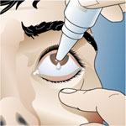
- Otic instillation
  - Aural – affected side up, straighten ear canal by pulling earlobe less than 3 y.o – down back, adult – up, down; drop into walls of ear canal not direct to tympanic membrane, maintain position for 10-15 minutes,
- Nasal drops

3. Inhalation
    - aerosolized liquids/gases administered into the respiratory tract
      - Nasal spray
      - Nebulization
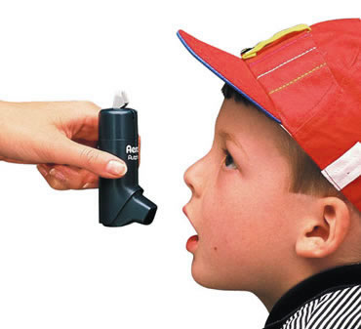

- Parenteral
- Means outside of intestines or alimentary canal. Referred as injection routes
- Also include inhalation, those placed on the skin and on mucous membranes
- Advantage:
  - rapid absorption
  - Results are more predictable
  - Desired dosage can be determined with greater accuracy

- Routes:
- IV - Intravenous (fastest delivery into the blood circulation)
- IM – Intramuscular
- Sites:
    - Dorsogluteal
    - Ventrogluteal
    - Vastus lateralis
    - Rectus femoris
    - Deltoid muscle

- Considerations for Intramuscular Administration
  - Used for drugs that are irritating since there are few nerve endings in deep muscle tissue
  - It is best to palpate a muscle prior to injection
  - Site should not feel tender and where the tissue doesn’t contract to be firm and tense
  - Should not be more than 5 ml
  - Absorption more rapid sue to greater vascularity of muscle
  - Should be given away from large nerves, bones and blood vessels
- SC or SQ – Subcutaneous
  - Sites:
    - Upper arm
    - Thigh, lower abdomen, upper back
  - Sites should be rotated or it will irritate the site if not completely absorbed
  - Not more than 1 ml
  - Air lock – small air bubble retained to force medication remaining in the needle shaft into the site
- ID – Intradermal (diagnostic purpose)
  - Absorbed slowly via capillaries
  - Common site for injection is the inner aspect of the forearm
  - Advantage:
    - Body’s reaction to substance is easily visible, and by means of comparing, degrees of reaction are discernable
- Intrathecal – into subarachnoid space (anesthesia)
- Intraarticular – into a joint

Syringes and Needles
Factors to be considered in choosing the kind of syringe to be used
- Type of medication
- Amount of medication
- Method of dispensing the medication

Factors to be considered in choosing the kind of needle to be used
- Route of administration
- Med to be administered
- Size of the patient
- Effect of medication on tissues

Parts
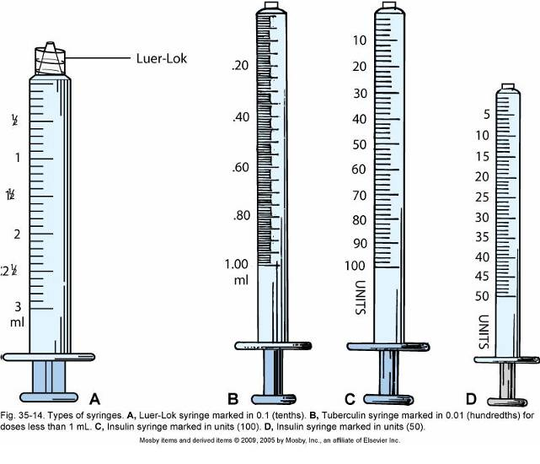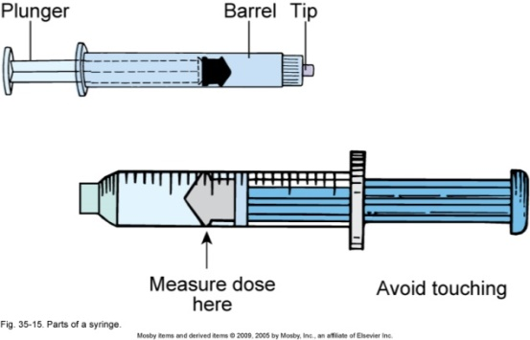

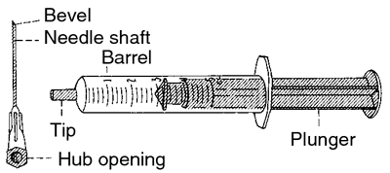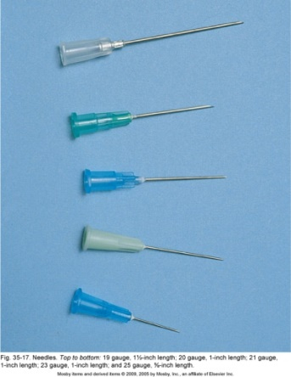

Routes
Route | Needle size | Needle length | Angle of injection
ID (intradermal) | Gauge 26 | ½ inch | 0-15 degrees
SC (subcutaneous) | Gauge 27, 26, 23 | ¾ inch | 45 degrees
IM (intramuscular) | Gauge 23, 22, 21 | 1 inch | 90 degrees

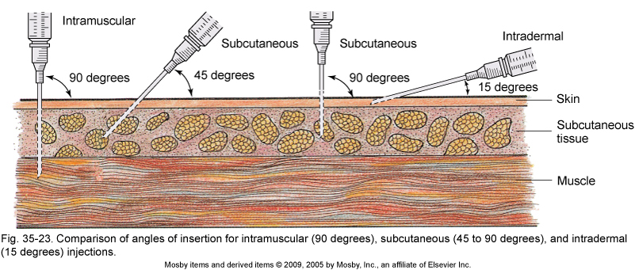

Drugs may be dispensed in:
- Single dose
- Glass ampules
  - Single dose
  - Multiple dose
- Rubber capped vials
  - Single dose
  - Multiple dose
- Cartridge

Points to remember
    - Do not take antacid with medications
    - Do not crush enteric-coated & sustained release tablets
    - Capsules should not be opened
    - Never adjust or change a medication dose or abruptly stop medication
    - Avoid alcohol and smoking
    - Question (and hold) medications if the order is unclear, or dose is not a normal one.

Preparing for Drug Administration
- Check the “15 rights”
- Standard Precautions: Wash your hands!
- Double-check if unsure about anything
- Check for drug allergies
- Prepare drugs for one patient at a time
- Check three times
- Check expiration dates
- Check the patient’s identification (2 identifiers)
- Give medications on time
- Document the medications given before going to the next patient

Parenteral Drugs
- Never recap a used needle!
- May recap an unused needle with the “scoop method”
- Filter needles – draw reconstituted meds to prevent precipitate from entering syringe
- Removing medications from ampules
- Removing medications from vials
- Disposal of used needles and syringes in sharps container

Injections
- Needle angles for various injections
  - Intramuscular (IM)
  - Subcutaneous (SC or SQ)
  - Intradermal (ID)
  - Z-track method for IM injections
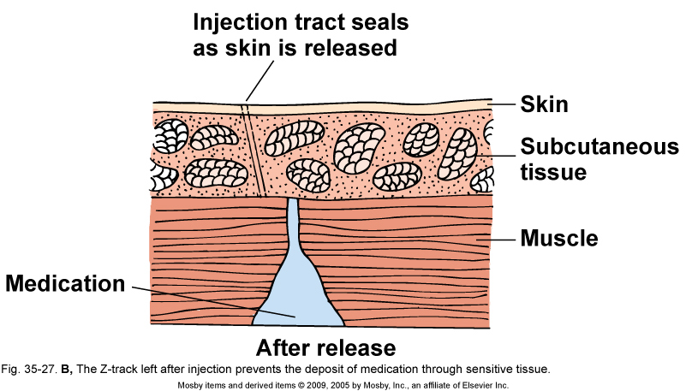
- Air-lock technique

Type of Medication Action
- Therapeutic - The expected or predictable physiological response of a medication. 1 med can have many effects
- Side - Unintended secondary effects. May be harmless or serious thus, must be discontinued
- Adverse effects - Undesirable and unexpected effects of drug unrelated to therapeutic effect. Must be reported to FDA. Could come from Adverse Drug Events or Adverse Drug Reactions (ADR)
- Toxic - May develop after prolonged intake, drug accumulation in blood, or excessive amount taken
- Idiosyncratic reactions - An unpredictable reaction different from normal. Genetically determined abnormal response. This drug reactions are usually caused by abnormal levels of drug-metabolizing enzymes (deficiency or overabundance)
- Allergic reaction – more than 10% of medications cause this. Medication acts as an antigen triggering the release of the body’s antibodies. Maybe d/t chemical preservative or a metabolite. INITIAL dose sensitized immunologically. REPEATED dose allergic response
- Severe reaction-Anaphylactic reaction
- Mild reaction- hives, rash, pruritis
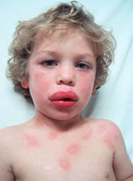

- Teratogenic - Structural effect in unborn fetus (thalidomide)
- Carcinogenic - Causes cancer
- Mutagenic - Changes genetic composition (radiation, chemicals)

- NURSING PROCESS AND THE MEDICATION

A. The Nursing Process
1. Assessment
- Data collection
  - Subjective, objective
  - Data collected on the patient, drug, environment
- Medication history
- Nursing assessment
- Physical assessment
- Data analysis

2. Implementation

Constant System Analysis
- A “double-check system” of entire medication administration - ordering, dispensing, preparing, administering, documenting
- Patient education.

The nurse must understand the importance of proper drug storage in order to maintain medications at their optimum potency. Some drugs must be refrigerated, some kept away from direct light, and some (narcotics) must be secured under double lock.

Documentation of medication administration should only be completed after the client has taken the medication. If the nurse documents the medication as given and then the client refuses the medication, it is essentially a medication error.

Calculation of drug dosages is the responsibility of the nurse. We will review the procedures for drug calculation a bit later. Dosage preparation involves pouring the medication or drawing it up in a syringe for administration. Some medications must be crushed and mixed with food or liquid for clients with difficulty swallowing.

Transcription is an area that has a high potential for error. Most facilities are moving from handwritten orders to computer generated ones to reduce the error rate. Each of these interventions has patient safety as its goal.

3. Evaluation
- Ongoing part of the nursing process
- Determining the status of the goals and outcomes of care
- Monitoring the patient’s response to drug therapy
  - Expected and unexpected responses
During the evaluation phase of the process, the nurse must determine how much progress the client has made toward the previously determined goals.

The nurse needs to ask:
- Is the medication doing what it was ordered to do?
- Is it doing it as well as expected?
- Are there any unexpected effects?
- Should the medication be changed, or continued as ordered?

- DRUG DOCUMENTATION

- MEDICATION ADMINISTRATION RECORDS (MAR)

Medication flow sheets usually include designated areas for the date of the medication order, the expiration date, the medication name and dose, the frequency of administration and route, and the nurse’s signature. Some records also include a place to document the client’s allergies.

A drug order is written on the client’s chart by a primary care provider or by a nurse receiving a telephone or verbal order from a primary care provider. Most acute care agencies have a specified time frame (e.g., 24 or 48 hours) in which the primary care provider issuing the telephone or verbal order must cosign the order written by the nurse. The nurse or clerk then copies the medication order to a Kardex or medication administration record (MAR). Increasingly, nurses receive computer printouts of a client’s medications instead of a copy of the primary care provider’s order. This method avoids errors and saves nursing time.

MARs vary in form, but all include the client’s name, drug name and dose; and times and method of administration. In some agencies, the date the order was prescribed and the date the order expires are also included. The nurse should always question the primary care provider about any order that is ambiguous, unusual (e.g., an abnormally high dosage of a medication), or contraindicated by the client’s condition.

- MEDICAL ABBREVIATIONS

Abbreviations
aa - of each
ac - before meals
ad lib - freely
aq - water
BID - twice a day
c - with
DC - discontinue
gtt - drop
h - hour
hs - at bedtime/hours of sleep
ID - intradermal
IM - intramuscular
IV - intravenous
PRN - as needed
qd - every day
qh - every hour
s - without
SS - one half
SOS - one time only
STAT - immediately
TID - thrice a day

- DOSAGE FORMS

Dosage forms is also known as pharmaceuticals. It is defined as a preparation devised to make possible administration of medications in measured or prescribed amount.

Definition of Terms:
- Parenteral Dosage Forms – are preparation introduced into the body by injection through the skin, the mucous, or the serous membranes
- Dosage forms for inhalation – are preparations intended to be finally dispensed or vaporized to the mucous membranes of the lower part of the respiratory tract.
- Oral Dosage Forms - are preparations intended to be taken orally.
- Rectal Dosage Forms - are preparations employed for systemic effect or a local action through the rectum.
- Dosage Forms For Topical application are preparations intended to be applied on the skin or instilled into eyes, nose, or ears.
- Pharmaceutical dosage form
- Determines the physical form of the final pharmaceutical preparation
- Is a drug delivery system which is formed by technological processing (drug formulation)
- Must reflect therapeutic intentions, route of administrations, dosing etc.
- Pharmaceutical preparation (PP)
- particular pharmaceutical product containing active and inactive pharmaceutical ingredients formulated into the particular dosage form.
- Packed and labelled appropriately
- Two major types of PP according the origin:
- Manufactured in large scales by pharmaceutical industry (original and generic preparations)
- Compounded individually in compounding pharmacies.

- Classification of Pharmaceutical Dosage Forms According to Physical Properties:
- Gaseous dosage forms
- Medicinal gases, inhalation/volatile anaesthetics (vaporised before administration by inhalation)
- Aerodispersions of solid particles (e.g., antiasthmatic inhalations) or liquid particles (antiasthmatic inhalations or sprays)

- Liquid dosage forms
- Solutions – one homogenous phase, prepared by dissolving one or more solutes in a solvent; it represents a group of preparations in which the molecules of the solute or dissolved substances are dispersed among those of the solvent.
- Water – used mainly as a vehicle and as a solvent for the desired flavoring or medicinal ingredients.
- Aromatic water – also known as medicated water, clear saturated aqueous solutions of volatile oils or aromatic or volatile substances.
- Aqueous acids – official inorganic acids and certain acids although of minor significance as therapeutic agents are great importance in chemical and pharmaceutical manufacturing.
- Diluted acids – aqueous solutions of suitable strength usually 10% w/v except diluted acetic acid which is 6% w/v
- Douches – aqueous solutions directed against a part or into a cavity of the body
- Enemas – also known as evacuation enemas. They are rectal injections employed to evacuate bowel retention enemas to influence the general system by absorption, or to effect locally the seat of disease.
- Gargles – aqueous solutions used for treating the pharynx and nasopharynx by forcing air from the lungs through the gargle which is held in the throat.
- Mouthwashes – aqueous solutions which are most often used for their deodorant, refreshing, or antiseptic effect.
- Juices (Succi)– prepared from fresh ripe fruits, aqueous in character and used in making syrups which are employed as vehicles; excellent way of taking medicinal herbs.
- Nasal solutions – usually aqueous solutions which are deigned to be administered to the nasal passages in drops or spray form.
- Otic solutions – aqueous preparations dispensed in a container which permits the administration of drops to the ear
- Other solutions:
- Linctuses (Lincti) – liquid preparations of a mucilaginous, syrupy, or viscous nature containing substances which possess demulcent, expectorant, or sedative properties. They are usually administered in small doses and should be directed to be sipped and swallowed slowly without the addition of water, so that they may form a temporary protective or remedial film over the membranes of the throat. Ex. Linctus Ipecacuanhae
- Non-aqueous
- Collodion –liquid preparations containing pyroxillin in a mixture of ethyl ether and ethanol.
- Elixirs – clear, pleasantly flavored sweetened hydro-alcoholic liquids intended for oral use.
- Glycerites – solutions or mixtures of medicinal substances in not less than 505 by weight of glycerin
- Inhalations – are solutions of drugs administeredby the nasal or oral respiratory route for local or systemic effect.
- Liniments – solutions or mixtures of various substances in oil, alcoholic solutions of soap or emulsions.
- Oleovitamins – fish liver oils diluted with edible vegetable oil or solutions of volatile substances of the indicated vitamins or vitamin concentrates (usually A and D) in fish liver oil.
- Spirits – known as essences; are alcoholic hydro-alcohol solutions of volatile substances.
- Toothache drops – preparations used for temporary relief of toothache by application of cotton saturated with the product into tooth cavity

- Emulsions
- a dispersion system consisting of two immiscible liquids with cloudy appearance
- a two phase system prepared by combining two immiscible liquids one of which is uniformly dispersed through the other; they consist of globules that have diameters equal to or greater than those of the largest colloidal particles.

- Suspensions
- A dispersion system where solid particles (dispersed phase) are dispersed in liquid phase (dispersion medium)
- According to the size of dispersed particles (1 nm- 0,5 mm) a molecular, colloidal and coarse dispersions can be distinguished
- May require shaking before administration
- Not intended for systemic administration of drugs with high potency

- Semisolid dosage forms
1. Unshaped (without specific physical shape)
- Gels -A semisolid systems in which a liquid phase is constrained within a 3D cross-linked matrix; a semisolid system of either suspension made up of small organic particles or large organic molecules interpenetrated by a liquid
- Creams – semisolid emulsion systems (o/w, w/o) containing more than 10% of water. More comfortable and cosmetically acceptable as they are less greasy and more easily water washable. Accommodate and release better lipophilic API, moisturizing, Cold creams
- Lotions – usually liquid suspension or dispersions intended for external application to the body.
- Magmas and milk – aqueous suspensions of insoluble inorganic drugs; they differ from gels mainly in that the suspended particles are layers.
- Tinctures – alcoholic or hydroalcoholic solutions prepared from vegetable materials or from chemical substances
- Fluidextracts – liquid preparation of vegetable drugs containing alcoholic as a solvent or as preservative or both, so made that each mL contains the therapeutic constituents of 1 g of the standard drug that it represents
- Extracts – concentrated preparations of vegetable or animal drugs obtained by removal of the active constituents of the respective drugs with suitable menstruum.
- Parenteral preparation – sterile preparations intended to be administered by injection under or through one or more layers of skin or mucous membranes
- Intravenous admixtures – mixture of intravenous fluids and drugs to be administered by injection
- Ointments – semisolid dosage forms with the oleaginous (hydrocarbon), water-soluble or emulsifying base
- Oleaginous (hydrocabon) base: Petrolatum (Vaseline – white, yellow)
- Water-soluble base: Polyethylenglycol (PEG)- ointment – syn. macrogol ointments
- Pastes – semisolid dispersion system, where a solid particles (> 25%, e.g. ZnO) are dispersed in ointments – mostly oleaginous (Petrolatum)

2. Shaped
- Suppositories (for rectal administration)
- different shapes; melting/dissolving at body temperature, oleaginous (cacao butter, adeps neutralis) or aqueous (PEGs, glycerinated gelatine)
- Pessaries (vaginal suppositories)
- Similar as above, PEGs or glycerinated gelatine are often used as base.

- Solid dosage forms
- Unshaped (without specific shape)
- powders for external/internal use
- Shaped
- Tablets
- Capsules
- Implantates (Sterile disks inserted surgically into body tissues and designed to release drug(s) over extended period of time)
- Transdermal patches
- Lozenges (consists of sugar and gum to medicate the mouth and throate)

- Classification pf Pharmaceutical Dosage Forms According to the Route of Administration
- For Systemic Administration
- Per orem (p.o)
- Sublingual (S.L) and buccal.
- Rectal
- Parenteral
- Transdermal
- Inhalation

B. For Local Administration
- Topical (on the skin or mucosa)
- Into/onto
- the eye, nose, ear
- the oral cavity
- the vagina, rectum
- the brochi
- the skin
- Local parenteral (viz Parenteral above)
- Oral (local effect within GIT; antacids, adsorbents

Type |  | Description
Aerosol spray or foam |  | A liquid, powder, or foam deposited in a thin layer on the skin by air pressure
Aqueous solution |  | One or more drugs dissolved in water
Aqueous suspension |  | One or more drugs finely divided in a liquid such as water
Caplet | 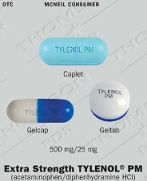 | A solid form, shaped like a capsule, coated and easily swallowed
Capsule | 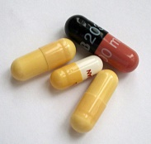 | A gelatinous container to hold a drug in powder, liquid, or oil form
Cream |  | A nongreasy, semisolid preparation used on the skin
Elixir | 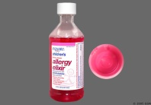 | A sweetened and aromatic solution of alcohol used as a vehicle for medicinal agents
Enteric coated tablet | 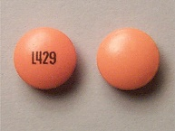 | Tablet for oral use coated with materials that don’t dissolve in stomach and intestine
Extract |  | A concentrated form of a drug made from vegetables or animals
Gel or jelly |  | A clear or translucent semisolid that liquefies when applied to the skin
Liniment | 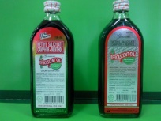 | A medication mixed with alcohol, oil, or soapy emollient and applied to the skin
Lotion |  | A medication in a liquid suspension applied to the skin
Lozenge (troche) | 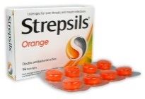 | A flat, round, or oval preparation that dissolves and releases a drug when held in the mouth
Ointment (salve, unction) | 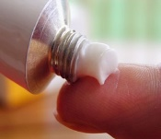 | A semisolid preparation of one or more drugs used for application to the skin and mucous membrane
Paste |  | A preparation like an ointment, but thicker and stiff, that penetrates the skin less than an ointment
Pill | 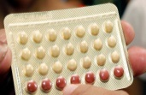 | One or more drugs mixed with a cohesive material, in oval, round, or flattened shapes
Powder |  | A finely ground drug or drugs; some are used internally, others externally
Suppository | 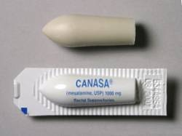 | One or several drugs mixed with a firm base such as gelatin and shaped for insertion into the body (e.g., the rectum); the base dissolves gradually at body temperature, releasing the drug
Suspension | 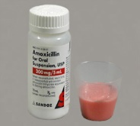 | Solid particles and liquid that must be shaken to disperse solid particles throughout the liquid portion
Syrup | 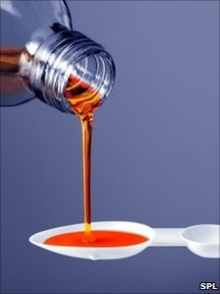 | An aqueous solution of sugar often used to disguise unpleasant-tasting drugs
Tablet |  | A powdered drug compressed into a hard small disk; some are readily broken along a scored line; others are enteric coated to prevent them from dissolving in the stomach  Types  - Scored – indented to allow tablet to be broken in half  - Unscored  - Enteric coated – candylike coated shell encases tablet to keep from being absorbed in stomach. Absorption must be in small intestine
Tincture | 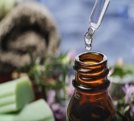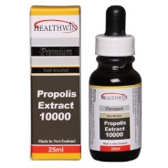 | An alcoholic or water-and-alcohol solution prepared from drugs derived from plants
Transdermal patch | 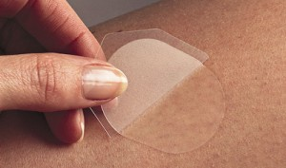 | A semipermeable membrane shaped in the form of a disk or patch that contains a drug to be absorbed through the skin over a long period of time

- Need of Dosage Forms
- To provide for the safe and convenient delivery of accurate dosage
- Examples: Tablets, Capsules, syrups
- For the protection of a drug substance from the destructive influence of atmospheric oxygen or moisture.
- Examples: coated tablets, sealed ampules
- For the protection of a drug substance from the destructive influence of gastric acid after oral administration.
- Example: enteric coated tablets
- To conceal the bitter taste, salty obnoxious or odor of a drug substance.
- Examples: Capsules, coated tablets, flavored syrups
- To provide liquid preparations of substances that are either insoluble or unstable in the desired vehicle.
- Example: suspension
- To provide liquid dosage forms of substances soluble in desired vehicle.
- Example: solution
- To provide extended drug action through controlled release mechanisms
- Examples: controlled release tablets, capsules, suspensions
- To provide optional drug action from topical administration sites
- Examples: ointments, creams, ophthalmic, ear and nasal preparations
- To provide for insertion of a drug into one of the body’s orifices
- Examples: rectal and vaginal suppositories
- To provide for the placement of drugs within body tissues.
- Examples: Implants
- To provide for the optimal drug action through inhalation therapy.
- Examples: inhalants and inhalations
- In addition, many dosage forms permit ease of drug identification through distinctiveness of color, shape, or identifying markings

- SYSTEMS OF MEASUREMENT WITH CONVERSION

Measuring Systems:
- Metric system – most widely used system of measure. Based on decimal system.
  - Gram – basic unit of solid measure.
  - Liter – basic unit of liquid measure
- Apothecary system – uses Roman numerals.
- Minim – liquid measure
- Grain solid measure
  - ex. 15 grains - gr XV
- Household system - Found in recipe books
- Teaspoon – fluid measure
- Pound – solid measure
- Avoirdupois system – used for bulk medications coming directly from manufacturer
- Other systems
- mEq (milliequivalents) for electrolytes – ionic activity of the drug
- IU – vitamins or enzymes
CONVERSION (memorize other units used in drug computations)
1 liter (L) = 1000 ml (milliters)
1 gram (g) = 1000 mgs (milligrams)
1 mg (milligrams) = 1000 mcgs (micrograms)
1 gram (g) = 15 grain (gr)
1 grain (gr) = 60 mg (milligrams)
1 dram (dr) = 4 ml (milliters)
1 ounce (oz) = 30 ml (milliters)
1 tsp (teaspoon) = 5 ml (milliters)
1 tbs (tablespoon) = 15 ml (milliters)
1 kg (kilogram) = 2.2 lbs (pounds)
1 inch = 2.54 cm (centimeters)
16 ounces (ozs) = 1 lb (pound)
1 cup = 8 ounces (ozs)
1 ml (milliter) = 15 minims
1 tsp (teaspoon) = 5 ml (milliters)
1 tbs (tablespoon) = 15 ml (milliters)
1 drop (gtt) = 15 minims

Conversion Rule
Rule 1: To convert a quantity in the metric system to a larger metric unit (e.g., mg to g), move the decimal point to the left.
-Smaller to larger (S to L) = Right to left (R to L)
Example: 2.0 mg ------- 0.002 g

Rule 2: To convert a quantity to a smaller metric unit, move the decimal point to the right.
-Larger to smaller (L to S) = Left to Right (L to R)
Example: 2.4L ---------- 2400.0 mL

- DOSAGE CALCULATIONS AND METHODS FOR CALCULATIONS: CALCULATIONS FOR ORAL, INJECTABLE DOSES AND INTRAVENOUS FLUIDS

Drug Computations

Methods of Calculating Dosages
- Four common formulas are used to calculate drug dosages. Any of the formulas can be used. Nursing students are encouraged to review all four and to choose the method that works best for them. It is important to use one method consistently to avoid confusion in calculations and, thus, promote client safety. When calculating drug dosages, there are times when the nurse may need to round numbers

- Basic Formula
The basic formula for calculating drug dosages is commonly used and easy to remember:
D = desired dose (i.e., dose ordered by primary care provider)
H = dose on hand (i.e., dose on label of bottle, vial, ampule)
V = vehicle (i.e., form in which the drug comes, such as tablet or liquid).

Formula $=\frac{D}{H} x V=$Amount to Administer

Example Order: Erythromycin 500 mg
On hand: 250 mg in 5 mL
D = 500 mg H = 250 mg V = 5 mL

$$=\frac{500 mg }{250 mg} x 5mL= \frac{2,500}{502}=10mL$$

- Ratio and Proportion
The ratio and proportion method is considered the oldest method used for calculating dosage problems. The equation is set up with the known quantities on the left side (i.e., H and V). The right side of the equation consists of the desired dose (i.e., D) and the unknown amount to administer (i.e., x). The equation looks like this:

H : V :: D : x
Once the equation is set up, multiply the extremes (i.e., H and x) and the means (i.e., V and D). Then solve for x.

H = 250 mg: V = 1 capsule:: D = 750 mg : x
250 : 1 :: 750 : x

Multiply the extremes (i.e., H and x) and the means (V and D):
250x = 750 x = 3 tablets

- Fractional Equation Method
The fractional equation method is similar to ratio and proportion, except it is written as a fraction:

$\frac{H}{V}$ = $\frac{D}{X}$

The formula consists of cross multiplying and solving for x:

$\frac{H}{V}$ = $\frac{D}{X}$

Hx = DV

X = $\frac{DV}{H}$

Example Order: Lanoxin 0.25 mg
On hand: Lanoxin 0.125 mg tablets
$\frac{0.125 mg}{1 tablet}$ = $\frac{0.25 mg}{X}$

Cross multiply:
0.125 x = 0.25
Solve for x:
$\frac{0.125 x}{0.125}$ = $\frac{0.25}{X}$

X = 2 tablets

- Dimensional Analysis
The dimensional analysis method is often used in the physical sciences when a quantity in one unit of measurement is converted to an equivalent quantity in a different unit of measurement by canceling matching units of measurement. In some of the previous examples, the nurse needed to convert from one or two systems to one system and unit of measurement. This involved extra steps or equations. One advantage of dimensional analysis is that only one equation is needed. The three components (D, H, and V) are still needed to solve the problem. However, when the units of measurement differ for D and H, the dimensional analysis method includes the conversion factor in the equation.

Six steps are suggested when using dimensional analysis:
- Identify the dose on hand.
- Identify the desired dose.
- Write down the conversion factor, if needed.
- Set up the equation.
- Cancel units that appear in the numerator and denominator.
- Multiply the numerator. Multiply the denominator. Divide the products.

Example:
Order: Valsartan 120 mg
On hand: Valsartan 40 mg tablets
      - Identify the dose on hand: 40 mg
      - Identify the desired dose: 120 mg
      - No conversion is needed.
      - Set up the equation. Remember to put V (the form in which the drug comes) in the numerator:

$\frac{1 tablet}{40 mg}$ x $\frac{120 mg}{1}$

      - Cancel units:
$\frac{1 tablet}{40 mg}$ x $\frac{120 mg}{1}$

      - Multiply the numerator and denominator and then divide:

$\frac{1 tablet}{4}$ x $\frac{120}{1}$ = $\frac{120}{40}$ = 3 tablets

Calculation for Individualized Drug Dosages
- Nurses often need to individualize the dosage of a medication for pediatric clients. Other clients who may require an individualized dosage include those receiving chemotherapy and clients who are critically ill. The two methods for individualizing drug dosages are body weight and body surface area.

A. Body Weight
Unlike adult dosages, children’s dosages are not always standard. Body weight significantly affects dosage; therefore, dosages are calculated. Dosages based on weight use kilograms of body weight and per kilogram medication recommendations to arrive at appropriate and safe doses. The steps involved in calculating an individualized dose are as follows:
  - Convert pounds to kilograms.
  - Determine the drug dose per body weight by multiplying drug dose × body weight × frequency.
  - Choose a method of drug calculation to determine the amount of medication to administer.

Example:
Order: Keflex, 20 mg/kg/day in three divided doses. The client weighs 20 pounds.
On hand: Keflex oral suspension 125 mg per 5 mL
- Convert pounds to kilograms: 20 ÷ 2.2 = 9 kg
- Multiply drug dose × body weight × frequency:
20 mg * 9 kg = 1 day = 180 mg/day
180 ÷ 3 divided doses = 60 mg per dose

- The nurse chooses his or her preferred method of calculation (e.g., basic formula, ratio and proportion, fractional, dimensional analysis) to determine how many milliliters per dose of medication. (The answer is 2.4 mL per dose.)

B. Body Surface Area
Sometimes the body surface calculation may be used instead of body weight to individualize the medication dosage. It is considered to be the most accurate method of calculating a child’s dose. Body surface area is determined by using a nomogram and the child’s height and weight. Figure below shows a standard nomogram that will give a child’s body surface area based on the weight and height of the child.

The formula is the ratio of the child’s body surface area to the surface area of an average adult (1.7 square meters, or 1.7 m2), multiplied by the normal adult dose of the drug:

$\frac{Child’s dose = surface area of child(m2)}{1.7 m²}$ X normal adult dose

For example, a child who weighs 10 kg and is 50 cm tall has a body surface area of 0.4 m2. Therefore, the child’s dose of tetracycline corresponding to an adult dose of 250 mg would be as follows:

$\frac{0.4 (surface area of child)}{1.7 (surface area of average adult)}$ = 0.2

0.2 + 250 (normal adult dose) = 50 mg

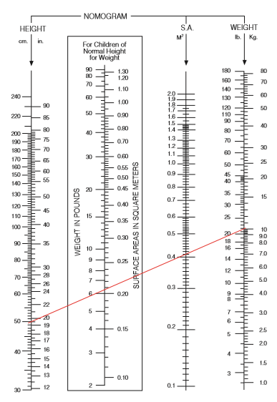

Intravenous Fluid Therapy
- Involve administration of water, nutrients, electrolytes, blood products and medications directly to vein. Types:
- Continuous
- Intermittent
- Given via IV infusion set
- Primary line – peripheral (access into arm) or central (access into large vein in chest or neck)
- Secondary line – IVPB

Intravenous Fluid computations

mL/hr x drop factor (gtts/mL)
time in minutes

macro drop factor = 10 gtts/mL if blood set or 15 gtts/mL for usual brands of IV set
micro drop factor = 60 gtts/mL for pediatric IV sets

Examples:
- An order has been written for a patient to receive 400 ml of 5% D5W over a period of 4 hrs in a microdrip system. Calculate the correct setting.
- An order has been written for a patient to receive 400 ml of 5% D5W over a period of 4 hrs in a macrodrip system. Calculate the correct setting.
- An order is written for a patient to receive 50 mL of antibiotic over 30 minutes. The IV set used dispenses 60 drops/mL. Calculate how fast the delivery should be.

- PEDIATRIC DRUG CALCULATIONS

Pediatric Considerations
- FRIED’S RULE - applies to less than 1 yr old. Adult dose applies to a 150 month old (12.5 yrs old)
Child dose (less than 1 yr old) = age in months/150 months x average adult dose

- YOUNG’S RULE – apply to 1-12 yrs old
Child dose (1-12 yrs old) = age in years/(age in years + 12) x average adult dose

- CLARK’S RULE - uses weight. Assumes that adult dose is 150 Lb
Child dose = weigh in lb/150 x average adult dose

- Body Surface Area – use of nomogram
Child’s dose = surface area (m2)/1.73 x AAD

- MEDICATION ERRORS

Medication Errors: Preventing and Responding
- Medication Errors – Preventable and Common cause of adverse health care outcomes
- Common classes of Medication Involved in Serious Errors
  - Antibiotics
  - Anticoagulants
  - Antidianetic agents (particularly insulin)
  - Antineoplastic (anticancer) agents
  - Cardiovascular agents
  - CNS-active agents (e.g. opiates, anesthetics)
  - Vaccines

Preventing Medication Errors
- Minimize verbal or telephone orders.
- List indication next to each order.
- Avoid medical shorthand, including abbreviations and acronyms.
- Never assume anything about items not specified in a drug order (i.e., route).
- Do not hesitate to question a medication order for any reason when in doubt.
- Do not try to decipher illegibly written orders; contact prescriber for clarification.
- NEVER use “trailing zeros” with medication orders.
- ALWAYS use a “leading zero” for decimal dosages.
  - Do not use .25 mg; use 0.25 mg
  - .25 mg may be misread as 25 mg
  - “.25” is sometimes called a “naked decimal”
- Check expiration date.
- Verify patient identification.
- If calculations needed, check computations.
- Always listen to and honor any concerns expressed by patients regarding medications.
- Check patient allergies.
- Medication Reconciliation.

Half-life - The time it takes for one half of the original amount of a drug in the body to be removed
- A drug’s half-life is used to determine how often a drug must be administered in order to maintain its therapeutic level.
- Half-life measures the rate at which a drug is removed from the body. It measures the time it takes for half of the original drug concentration to be removed.

Onset - time to elicit an action

Peak - time to reach maximum effect

Duration - time a drug concentration is sufficient to elicit an action

DRUG ABUSE
- Street drugs –non-Rx drugs with no known therap. use. Enhance pleasure and mood

Monitoring
- The effectiveness of the drug therapy must be evaluated
- One must be familiar with the drug’s:
  - Intended therapeutic action (beneficial)
  - Unintended but potential side effects (predictable, adverse reactions)

Therapeutic index
- The ratio between a drug’s therapeutic benefits and its toxic effects.
- Determines the safety of the drug.
- If a drug has a low therapeutic index, it has a high risk for toxicity.
- The nurse is responsible for monitoring drug levels (ie. digoxin, theophylline, lithium)

Medication misadventures
- Adverse drug events: any undesirable occurrence involving meds
- Adverse drug reactions: unexpected, undesirable drug reactions occurring at therapeutic levels
- Medication errors: preventable situations. One of the med. R’s is compromised

Answering Pharmacology Questions
Points to Remember
- Do not take antacid with medications.
- Do not crush enteric-coated & sustained release tablets.
- Capsules should not be opened.
- The nurse never adjusts or changes a medication dose or abruptly stops medication.
- Avoid alcohol and smoking.
- Question (and hold) medications if the order is unclear, or dose is not a normal one.

Life Span Considerations
- Pregnancy
- First trimester - period of greatest danger for drug-induced defects

Safety during Pregnancy
- As part of the standards for testing and safety, the FDA requires that each new drug be assigned to a pregnancy category. The categories indicate a drug’s potential or actual teratogenic effects, thus offering guidelines for use of that particular drug in pregnancy. Research into the development of the human fetus, especially the nervous system, has led many health care providers to recommend that no drug should be used during pregnancy because of potential effects on the developing fetus. In cases in which a drug is needed, it is recommended that the drug of choice be one for which the beneﬁt outweighs the potential risk.

- The U.S. Food and Drug Administration (FDA) have established ﬁve categories to indicate the potential for a systemically absorbed drug to cause birth defects. The key differentiation among the categories rests on the degree (reliability) of documentation and the risk–beneﬁt ratio.

- Category A: Adequate studies in pregnant women have not demonstrated a risk to the fetus in the ﬁrst trimester of pregnancy, and there is no evidence of risk in later trimesters.

- Category B: Animal studies have not demonstrated a risk to the fetus but there are no adequate studies in pregnant women, or animal studies have shown an adverse effect, but adequate studies in pregnant women have not demonstrated a risk to the fetus during the ﬁrst trimester of pregnancy, and there is no evidence of risk in later trimesters.

- Category C: Animal studies have shown an adverse effect on the fetus but there are no adequate studies in humans; the beneﬁts from the use of the drug in pregnant women may be acceptable despite its potential risks, or there are no animal reproduction studies and no adequate studies in humans.

- Category D: There is evidence of human fetal risk, but the potential beneﬁts from the use of the drug in pregnant women may be acceptable despite its potential risks.

- Category X: Studies in animals or humans demonstrate fetal abnormalities or adverse reaction; reports indicate evidence of fetal risk. The risk of use in a pregnant woman clearly outweighs any possible beneﬁt.

Regardless of the designated Pregnancy Category or presumed safety, no drug should be administered during pregnancy unless it is clearly needed.

- Breast-feeding
- Breast-fed infants are at risk. Consider risk-to-benefit ratio

- Infants and Children
  - Knowledge of growth and development is essential for the nurse administering medications to children. Oral medications for children are usually prepared in sweetened liquid form to make them more palatable. The parents may provide suggestions about what method is best for their child. Do not use necessary foods such as milk or orange juice to mask the taste of medications, because the child may develop unpleasant associations and refuse that food in the future.
  - Children tend to fear any procedure in which a needle is used because they anticipate pain or because the procedure is unfamiliar and threatening. The nurse needs to acknowledge that the child will feel some pain; denying this fact only deepens the child’s distrust. After the injection, the nurse (or the parent) can cuddle and speak softly to the infant and give the child a toy to dispel the child’s association of the nurse only with pain.

Pediatric Considerations: Pharmacokinetics
- Absorption
  - Gastric pH less acidic
  - Gastric emptying is slowed
  - Topical absorption faster through the skin
  - Intramuscular absorption faster and irregular

- Distribution
  - Total Body water (TBW)
    - 70% to 80% in full-term infants
    - 85% in premature newborns
    - 64% in children 1 to 12 years of age
  - Greater TBW, fat content is lower
  - Decreased level of protein binding
  - Immature blood-brain barrier

- Metabolism
  - Liver immature
  - Older children - increased metabolism, requiring higher doses

- Excretion
  - Kidney immaturity: Decreased excretion of drugs

Summary of Pediatric Considerations
- Skin is thin and permeable
- Stomach lacks acid to kill bacteria
- Lungs lack mucus barriers
- Body temperatures poorly regulated and dehydration occurs easily
- Liver and kidneys are immature, impairing drug metabolism and excretion

Geriatric Considerations
- Older adults can have special problems, most of which are related to physiological changes, to past experiences, and to established attitudes toward medications
- The geriatric population uses the largest amount of medications of any population group.
- It is especially important for the nurse to review the OTC medications an older client uses, as they may interfere with prescription drugs ordered.
- Polypharmacy exists when two or more meds cause an interaction or adverse reaction, are used for the same purpose, or have no apparent clinical rationale for use

Poly pharmacy is causes by:
- Lack of information
- Self-treatment
- Multiple physicians
- Use of folk remedies
- Lack of communication with physicians
- Overprescribing
- Multiple chronic diseases needing meds

Geriatric Considerations: Pharmacokinetics
- Absorption
  - Gastric pH less acidic
  - Slowed gastric emptying
  - Reduced blood flow to the GI tract
  - Reduced absorptive surface area due to flattened intestinal villi

- Distribution
  - TBW is lower
  - Fat content increased
  - Decreased protein binding

- Metabolism
  - Aging liver produces less enzymes
  - Reduced blood flow to the liver

- Excretion
  - Decreased glomerular filtration rate & number of nephrons

Geriatric Considerations: Problematic Medications
- Analgesics – commonly cause confusion, constipation, urinary retention, nausea, vomiting, respiratory depression, decreased LOC, and falls
- Anticoagulants – major/minor bleeding, many drug interactions, dietary interactions
- Anticholinergics – blurred vision, dry mouth, constipation, confusion, urinary retention, tachycardia
- Antihypertensives – nausea, hypotension, diarrhea, bradycardia, heart failure, impotence
- Digoxin – visual disorders, dysrhythmias, hallucinations, weight loss
- Sedatives/Hypnotics – confusion, daytime sedation, ataxia, lethargy, forgetfulness, risk for falls
- Thiazide diuretics – electrolyte imbalance, rash, fatigue, leg cramps, dehydration

LEGAL, ETHICAL, AND CULTURAL CONSIDERATIONS
U.S. Drug Legislation
- 1906: Federal Food and Drug Act – required manufacturers to list dangerous/addictive substances on the label; recognized US Pharmacopeia & National Formulary as printed standard reference for drugs
- 1912: Sherley Amendment (to the Federal Food and Drug Act of 1906) - prohibited fraudulent claims for drug products
- 1914: Harrison Narcotic Act - established the term narcotic; regulated manufacture and sale of habit-forming drugs
- 1938: Federal Food, Drug, and Cosmetic Act (revision of 1906 Act) - manufacturers required to provide safety information with FDA review; established the process for new drug application process
- 1951: Durham-Humphrey Amendment (to the 1938 act) - required prescriptions to carry the legend “Caution – Federal law prohibits dispensing without a prescription”
- 1962: Kefauver-Harris Amendment (to the 1938 act) - manufacturers required to demonstrate both therapeutic efficacy and safety
- 1970: Controlled Substance Act - established schedules for controlled substances; promoted drug addiction education, research and treatment
- 1983: Orphan Drug Act - enabled the FDA to promote research and marketing of orphan drugs used to treat rare diseases
- 1991: Accelerated drug approval - enabled faster approval process by the FDA for drugs used to treat life-threatening illnesses (AZT for AIDS)

Module Summary
- Pharmacodynamics is the study of the way that drugs affect the body.
- Most drugs work by replacing natural chemicals, by stimulating normal cell activity, or by depressing normal cell activity.
- Chemotherapeutic agents work by interfering with normal cell functioning, causing cell death. The most desirable chemotherapeutic agents are those with selective toxicity to foreign cells and foreign cell activities.
- Drugs frequently act at speciﬁc receptor sites on cell membranes to stimulate enzyme systems within the cell and to alter the cell’s activities.
- Pharmacokinetics—the study of the way the body deals with drugs—includes absorption, distribution, biotransformation, and excretion of drugs.
- The goal of established dosing schedules is to achieve a critical concentration of the drug in the body. This critical concentration is the amount of the drug necessary to achieve the drug’s therapeutic effects.
- Arriving at a critical concentration involves a dynamic equilibrium among the processes of drug absorption, distribution, metabolism or biotransformation, and excretion.
- Absorption involves moving a drug into the body for circulation. Oral drugs are absorbed from the small intestine, undergo many changes, and are affected by many things in the process. IV drugs are injected directly into the circulation and do not need additional absorption.
- Drugs are distributed to various tissues throughout the body depending on their solubility and ionization. Most drugs are bound to plasma proteins for transport to reactive tissues.
- Drugs are metabolized or biotransformed into less toxic chemicals by various enzyme systems in the body. The liver is the primary site of drug metabolism or biotransformation. The liver uses the cytochrome P450 enzyme system to alter the drug and start its biotransformation.
- The ﬁrst-pass effect is the breakdown of oral drugs in the liver immediately after absorption. Drugs given by other routes often reach reactive tissues before passing through the liver for biotransformation.
- Drug excretion is removal of the drug from the body. This occurs mainly through the kidneys.
- The half-life of a drug is the period of time it takes for an amount of drug in the body to decrease to one half of the peak level it previously achieved. The half-life is affected by all aspects of pharmacokinetics. Knowing the half-life of a drug helps in predicting dosing schedules and duration of effects.
- The actual effects of a drug are determined by its pharmacokinetics, its pharmacodynamics, and many human factors that can change the drug’s effectiveness.
- To provide the safest and most effective drug therapy, the nurse must consider all of the possible factors that inﬂuence drug concentration and effectiveness.

MODULE EVALUATION/ ASSESSMENT:

- The physician orders 1,000,000 units of Penicillin G for a client. The Pen G on hand available as a solution containing 250,000 units/mL.

- The physician orders 250 mcg of cyanocobalamin (Vit B) IM daily. Available on hand is labeled 1,000 mcg/mL. How many mL should be given to the client?

- The physician orders thiabendazole chewable tablets for a 110-pound child. The recommended dosage for is 20mg/kg per dose. How many 500mg tablets should be given to this client for each dose?

- The physician orders thiabendazole chewable tablets for a 110-pound child. The recommended dosage for is 20mg/kg per dose. How many 500mg tablets should be given to this client for each dose?

- The recommended dose of meperidine is 6mg/kg/24 hours for pain. It is given in divided doses every 4-6 hours. How many mL of meperidine injection (50 mg/mL) should be administered to a 33-pound child as a single dose every 6 hours?

- The recommended dose of cefamandole nafate (Mandol) for a pediatric client is 50mg/kg/day. How many mg must be given daily to a 60-pound child?

- A recommended dose for the administration of streptomycin sulfate is 10mg/lb/day. How many mg of this drug must be administered daily to a 63kg adult?

- An order is written for gr X of aspirin. The tablets that are available each contain 5 grains. How many tablets should be given?

- The physician prescribes 0.05 g Aldactone to be given orally (PO). The Aldactone is available in 25 mg tablets. How many tablets would you have to give?

- The doctor prescribes 250 mg cefuroxime. The bottle states that the solution contains 125 mg/5 ml. how much of the liquid should you give?

- An order has been written for 75 mg meperidine to be given IM. The vial states that it contains 50 mg/ml meperidine. How much of the drug should you give?

- The doctor prescribes 0.25 mg of Lanoxin. The pharmacist dispenses a stock of 500 mcg/2 ml of the drug. How much of the drug should the nurse give?

ADDITIONAL RESOURCES

REFERENCES

