Module No. 9
ANTINEOPLASTIC AGENTS

LESSON OVERVIEW:
The use of the term chemotherapy implies cancer treatment to most people. However, only one branch of chemotherapy involves drugs developed to act on and kill or alter human cells—the antineoplastic agents, which are designed to ﬁght neoplasms, or cancers. Antineoplastic drugs alter human cells in a variety of ways. Their action is intended to target the abnormal cells that compose the neoplasm or cancer, having a greater impact on them than on normal cells. Unfortunately, normal cells also are affected by antineoplastic agents.

This area of pharmacology, which has grown tremendously in recent years, now includes many drugs that act on or are part of the immune system. These substances ﬁght the cancerous cells using components of the immune system instead of destroying cells directly. This module discusses the classic antineoplastic agents and includes those drugs that are used in cancer chemotherapy.

LEARNING OUTCOMES:
Upon completion of this module, you will be able to:
- Describe the nature of cancer and the changes the body undergoes when cancer occurs.
- Describe the therapeutic actions, indications, pharmacokinetics, contraindications, most common adverse reactions, and important drug–drug interactions associated with each class of antineoplastic agents and with adjunctive therapy use with these drugs.
- Discuss the use of antineoplastic drugs across the lifespan.
- Compare and contrast the prototype drugs for each class of antineoplastic agents with the other drugs in that class.
- Outline the nursing considerations and teaching needs for patients receiving each class of antineoplastic agents.

POWER WORDS!

READINESS TEST:

DISCUSSION
- Introduction in brief of oncologic nursing on characteristics of cancer
- Principles of chemotherapy
  - Growth fraction and success of chemotherapy
  - Special pharmacotherapy, protocols and strategies for cancer chemotherapy
  - Toxicity of antineoplastic agents
- Anti-neoplastic agents and its classifications

Characteristics of cancer cells:
- Anaphasia – loss of cellular differentiation and organization
- Autonomy – growing without the usual homeostatic restrictions that regulate cell growth and control
- Metastasis – travelling of neoplastic cells from the place of origin to develop new tumors in other areas of the body favourable for cell growth
- Angiogenesis – abnormal cells release enzymes that generate blood vessels in the area to supply oxygen and nutrients to the cells

LOSS OF NORMAL GROWTH CONTROL IN CANCER
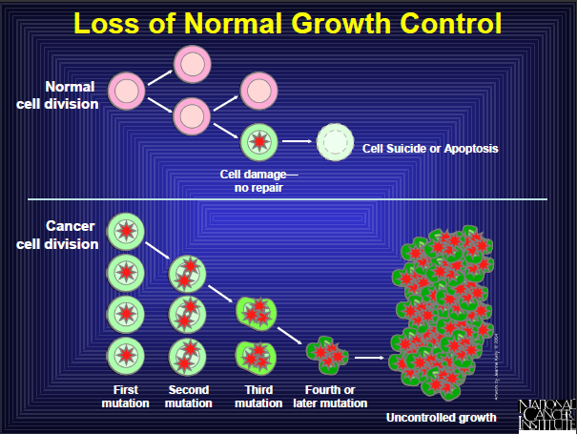

Mechanism of Action
- Alkylating Agents: Work by disrupting cellular mechanisms that affect DNA, causing cell death
- Antimetabolites: inhibit DNA production in cells that depend on certain natural metabolites to produce their DNA.
  - Considered to be S phase specific in the cell cycle
- Antineoplastic Antibiotics cycle-specific; cytotoxic and interfere with DNA synthesis by inserting themselves between base pairs in the DNA causing a mutant DNA molecule leading to cell death.
- Mitotic Inhibitors: interfere with the ability of a cell to divide; they block or alter DNA synthesis,
- They work in the M phase of the cell cycle.
- Kill cells as the process of mitosis begins
- Cell cycle specific agents that inhibit DNA synthesis
- Hormones and Hormone Modulators
- Receptor site specific or hormone specific to lock the stimulation of growing cancer cells that are sensitive to the presence of that hormone

Indications:
- Alkylating Agents: lymphomas, leukemias, myelomas, ovarian, testicular and breast cancer, pancreatic cancer
- Antimetabolites: various leukemias, GI and basal cancers
- Antineoplastic Antibiotics: tumors and leukemia
- Mitotic Inhibitors: tumors and leukemia
- Hormones and Hormone Modulators: breast cancer in post menopausal women, prostatic cancer

Sample Medications
A. Alkylating Agents
- busulfan (Myelaran)
- carboplatin (Paraplatin)
- carmustine (Giladel)
- chlorambucil (Leukeran) – gonadal suppression
- cisplatin (Platinol AQ) – ototoxicity, tinnitus, hypokalemia, hypocalcemia, hypomagnesemia
- cyclophosphamide (Cytoxan) – hemorrhagic cystitis
- ifosfamide (Ifex)
- lomustine (CeeNu)
- mechlorethamine (Mustargen) – gonadal suppression
- melphalan (Alkeran)[PO]
- oxaliplatin (Eloxatin)
- streptozocin (Zanosar)
- thiotepa (Thioplex )

B. Antimetabolites
- capecitabine (Xeloda)
- clofarabine (clolar)
- cytarabine (Cytosar U)
- floxuridine (FUDR)
- fludarabine (Fludara)
- fluorouracil (Adrucil)
- mercaptopurine (Purinethol)
- methotrexate (Rheumatrex)
- pemetrexed (Alimta)
- cladribine (Leucostatin)
- thioguanine (Nipent)

C. Antineoplastic Antibiotics
- bleomycin (Blenoxane)
- dactinomycin (Cosmegen)
- daunorubicin (DaunoXome)
- doxorubicin (Adriamycin)
- epirubicin (Ellence)
- idarubicin (Idamycin)
- mitomycin (Mutamycin)
- mitoxantrone (Novantrone)
- valrubicin (Valstar)

D. Mitotic Inhibitors
- docetaxel (Taxotere)
- etoposide (Toposar)
- paclitaxel (Taxol)
- teniposide (Vumon)
- vinblastine (Velban)
- vincristine (Oncovin)
- vinorelbine (Navelbine)

E. Hormones and Hormone Modulator
- anastrazole (Arimidex)
- bicalutamide (Casodex)
- estramustine (Emcyst)
- exemestane (Aromasin)
- flutamide (Eulexin)
- fulvestrant (Faslodex)
- goserelin (Zoladex)
- histrelin (Vantas)
- letrozole (Femara)
- leuprolide (Lupron)
- megestrol (Megace)
- nilutamide (Nilandron)
- tamoxifen (Nolvadex)
- testolactone(Teslac)
- toremifene (Fareston)
- triptorelin pamoate (Trelstar depot)

F. Cancer Cell-Specific Agents
- bortezomib (Velcade)
- erlotinib (Tarceva)
- gefitnib (Iressa)
- imatinib (Gleevac)

G. Miscellaneous Antineoplastic Agents
- altretamine (Hexalen)
- arsenic trioxide (Trisenox)
- asparaginase (Elspar)
- bortezomib (Velcade)
- dacarbazine (DTIC-Dome)
- gemcitabine (Gemzar)
- hydroxyurea (Hydrea)
- innotecan (Camptosar)
- mitotane (Lysodren)
- pegasparagase (Oncaspar)
- porfimer (Photofrin)
- procarbaine (Matulane)
- talc powder (Sclerosol)
- temozolomide (Temodar)
- topotecan (Hycamtin)
- tretinoin (Vesanoid)

Nursing Considerations
- Arrange for blood tests before, periodically during and for at least 3 weeks after therapy
- Administer medication according to the scheduled protocol and in combination with other drugs as indicated
- Ensure that the patient’s is well hydrated : IV
- Protect the patient’s from exposure to infection; limit invasive procedures when bone marrow suppression limits the patient’s inflammatory responses.
- Avoid people with infections or cold and avoid crowded and public places
- People caring for you should wear masks and gowns to protect you from germs.

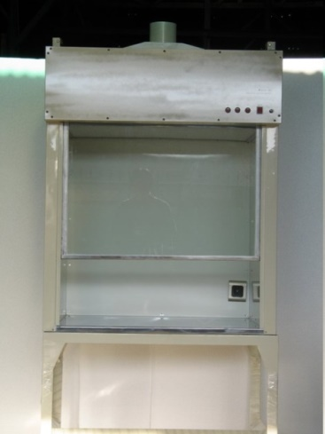
LAMINAR AIR FLOW SYSTEM
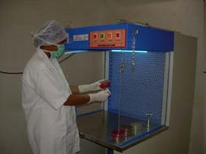

Antineoplastic Agents
- amifostine (Ethyol) – preserves healthy cells from the toxic effects of cisplatin
- mesna (Mesnex) – cytoprotective drugs that may be given to limit certain effects of cisplatin & ifosfamide in order to decrease hemorrhagic cystitis
- leucovorin is given to counter the effects of methotrexate

Antineoplastic Agents: Nursing Considertations
- Avoid working in the garden because soil can be full of bacteria.
- Provide small, frequent meals, frequent mouth care, and dietary consultation as appropriate Arrange for proper head covering at extremes of temperature if alopecia occurs
- If alopecia is an anticipated effect of drug therapy, advise the patient to obtain a wig or head covering before the condition occurs. Reassure that her hair will grow back
- Frequent mouth care and try to avoid very hot or spicy foods (mouth sores)
- Special care should be taken when shaving or brushing your teeth. Avoid activities that might cause an injury and avoid medications that contain aspirin
- Avoid direct skin or eye contact with the drug. Wear protective clothing and goggles while preparing and administering the drug to prevent toxic reaction.
- Initiate bleeding precautions if thrombocytopenia occurs
- Avoid IM
- Administer antiemetics several hours before chemotherapy and for 12 to 48 hours after as prescribed
- Allopurinol (Zyloprim) lowers the serum uric acid that results from the rapid destruction of the cells
- Prepare IV chemotherapy in an air vented space
- Wear gloves, gown, eye protectors and when handling IV medications
- Nurses who are pregnant should avoid chemotherapy preparation
- Monitor for extravasation
- Cisplatin: assess for dizziness, tinnitus, hearing loss, incoordination, numbness or tingling of extremities
- Monitor for s/s of hemorrhagic cystitis (hematuria, dysuria) during cyclophosphamide or ifosfamide therapy; EOF
- Assess for myocardial toxicity, dyspnea, dysrrhythmias, hypotension and weight gain when administering doxorubicin or idarubicin
- Bleomycin (Blenoxane): monitor resp. status
- When administering fluorouracil, assess for signs of cerebellar dysfunction such as dizziness, weakness, ataxia and assess for stomatitis, diarrhea
- When administering methotrexate in large doses, prepare to administer leucovorin
- When administering fluorouracil or methotrexate, protect the patient from photosensitivity

Checkpoint!
1. Cancer can be difficult to treat because
- Cells no longer progress through the normal cell cycle.
- Cells can develop resistance to drug therapy
- Cells can remain in the dormant state for long periods and emerge months to years later.
- The exact cause of cancer is not known

2. Antineoplastic drugs destroy human cells. They are most likely to cause cell death among healthy cells that
- Have poor cell membranes
- Are rapidly turning over and progress through their cell cycle rapidly.
- Are in dormant tissues
- Are across the blood brain barrier

3. Cancer treatment usually occurs in several different treatment phases. In assessing appropriateness of another round of chemotherapy for a particular patient, the nurse would evaluate
- Hair loss
- Bone marrow function
- Anorexia
- Heart rate

4. Patient teaching can be very important in helping the patient receiving cancer chemotherapy and should stress all of the following except
- The importance of keeping the head covered at extremes of temperature
- The need to use barrier contraceptives because of the risk of serious fetal effects
- Avoiding exposure to infection or to injury because the ability to heal or to fight infection is impaired
- The importance of avoiding food if nausea or vomiting is a problem

MODULE EVALUATION/ ASSESSMENT:

ADDITIONAL RESOURCES

REFERENCES

